**President’s Diversity, Equity, and Inclusion (DEI) Board**   
**Faculty Recruitment, Retention, and Development Subcommittee**

October 7, 2024 3:15-4:00 pm   
Zoom meeting Link <https://csusb.zoom.us/j/9095374336>

Meeting Room **-** Administration 103

**MEETING ATTENDANCE**

**Participants:**Check the box if present.

|  |  |
| --- | --- |
| ​​☐​   Kelly Campbell, Steering Committee Liaison | ​​☐​ Ted Young, Subcommittee Member |
| ​​☐​   ​​Lori Caruthers Collins, Chair | ​​☐​ Robert Kryiakos Smith, Subcommittee Member |
| ​​☐​   Angela Horner, Vice Chair | ​​☐​ Conrad Shayo, Subcommittee Member |
| ​​☐​   Marc Fudge, Subcommittee Member  ​​☐​   Jane Chin Davidson, Subcommittee Member | ☐​ Brad Owen, Subcommittee Member  ☐​ Carson Fajardo, Student Member  ​​​​​ |
| *Together we know a lot.*  *Take space, make space.*  *Uphold commitments and participation.*  *Talk in headlines.*  *Listen to understand.*  *Seek perspectives.*  *Create a “safe” environment that fosters mutual respect*  HSVE: Ice breakers - the best way to ... |  |
| **MEETING AGENDA** |  |

**1) Announcements** *(5 minutes)*

* Icebreaker –
* Community Agreements
* Upcoming DEI Events
  + - ***October 17 5:30 pm Alumni Center***

**The Temecula Massacre: A Forgotten Battlefield Landscape of the Mexican-American War**

Registration Link<https://csusb.az1.qualtrics.com/jfe/form/SV_4Tv2Px91Ik6wymG>[[emclick.imodules.com]](https://urldefense.com/v3/__https:/emclick.imodules.com/ls/click?upn=u001.GfCYurHEJjCTAlo1-2Fj7Ji1sqKF-2B2Gc-2B3CIsX8tySwpOV7Ko-2B2-2BYRPGV1439d47AC5SK1WDx3CcaLp0U9sI07Kfbm-2FeoPWipAryiaKhF2WCRvo3a7DScrAtHbpP0fatHyu2QKL9ClgqkQVgrRiYJAbA-3D-3DbpYG_J38k6-2F6nugWWzJj-2BIm6l6uPusKLWQaMSn2OcDr2nxvN2Zu-2Flw4WJkyn-2FP6pzbMTvzzApBm75lwl1adUZdc-2FzzzV1-2BWErehk4c3-2FlQINE3kju1-2Byk2I4GWm-2BWKny5DU4Nf6aUe2FxYE9yCCWwu-2F-2FtMTw-2Bq2G2lobxwpVNY81yWHVVnGNLRxPhGLU3PRx6LQx-2B7j30bVdRAbGAUqzIkY9rn7p-2BL32c11MZiMg2VqEPjPB9UBn3fdyVi-2F5VlPT6dyHcWS3mVV4olo9U-2ByOLBOIq6j8Z68FNk7W-2FAm-2Blk9bq7ZK3V4-2BRwBOT7ciLqidE5hD8wokR-2FzJBrrOKRLB8tj1Us8WBh4SmX4S7k-2FWUdXZSwdEZbsYmxKTPET16zI3EfjIRrKtcizo46B6zmq9sHSNQDI9lDoMaWRH0T5-2FyC1oU-2FXLmxfmKzyPxeu1ADa0nly9E4sU6VTJqb4WhndfiqxiL-2Be1eFnhC9mIzqLckxY4a8cGv67lze0rlg2kqQTq6G4-2FJUTlcZ26TydNsXPZ-2F1y7uUQ-3D-3D__;!!OM2WEIN1DMg!DCElwSjVIMVdrqTjll0VYQSZquGWD7QuJkKH-zhQazuqKIrjdTCrruj-gmea5n3awZf5cOOokEh2Ww3uiFwN$)

**2)** New **Discussion** *(20 minutes)*

**Identify what we need for each activity or task our subcommittee will undertake this year, specifically:**

* Plan Idea (Each separate undertaking should be listed in it’s own row)
* Which Strategic Plan Goal does this undertaking align with (Goal 1, 2, 3, or 4)
* Which Specific strategy or strategies does the undertaking align with (type out the strategy or use the strategy number)
* What are the intended outcomes of this undertaking (develop those in our committee and use the attached spreadsheet as a guide; what do we hope people will get out of this undertaking; keep in mind the intended outcomes should be related to our sub-committee charge)?
* How will we measure the effectiveness of this undertaking at the end of this academic year (use the measures in the attached spreadsheet, if they are relevant to our undertaking and make sure we can gather the data because we will be reporting on the extent to which outcomes were met)?
* How much funding are we requesting from the DEI board to carry out each undertaking? Additionally, we will be reporting on each of our undertakings, including outcome data, by June 2, 2025, or before faculty go off contract.

Google Sheet Link: <https://docs.google.com/spreadsheets/d/1PyT2XQbRZWy8vlQM8D4kd6iJyvn3PuX44g5sTUjAY_8/edit?gid=758262441#gid=758262441 [docs.google.com]>

1. Discuss activities/tasks/objectives to meet Goal 2 and Goal 3 using a SMART goals framework *(****S****pecific,* ***M****easurable,* ***A****ctionable,* ***R****ealistic,* ***T****ime-bound)*
2. Proposed budget $10,000 available
3. Think about “retention” as a component of our FRRD goals.
   1. *Partner with DEI Faculty Fellows (HERI data - BIPOC faculty discussion groups)*

**Goal 2: Faculty & Staff Success**

Attract and retain outstanding and dedicated staff and faculty by cultivating a safe environment where they thrive professionally and personally; in which their voices are represented, which fosters impactful collaborative partnerships.

**Goal 3: Diversity, Equity & Inclusion**

Advance an environment where every member of the university plays an active role in diversity, equity, and inclusion excellence through engagement, empowerment, education, and accountability.

**FRAMEWORK**

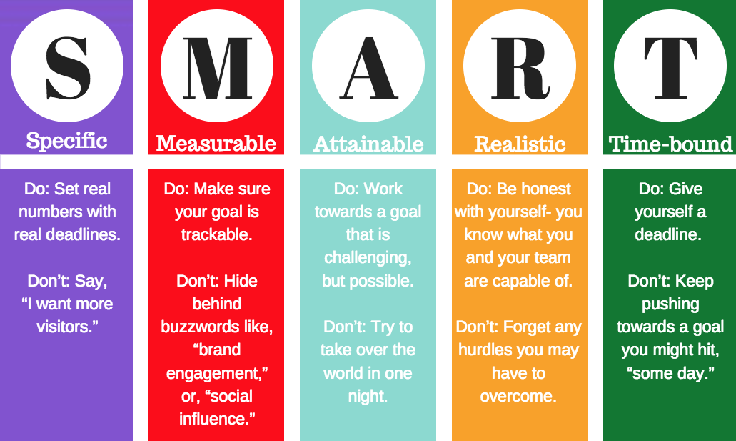

**3)** **Action Item** *(15 minutes)*

* Identify the goal(s) that you and or your partner(s) will take the lead on.

**4) Kelly Campbell - Steering Committee Liaisons Closing** *(5 minutes)*



* October 28 Zoom
* November 18 Admin rm 103
* December 2 Zoom
* December 16 Admin rm 103