**President’s Diversity, Equity, and Inclusion (DEI) Board**   
**Faculty Recruitment, Retention, and Development Subcommittee**

September 23, 2024 3:15-4:00 pm   
Zoom meeting Link <https://csusb.zoom.us/j/9095374336>

Meeting Room Location Administration rm 103

**MEETING ATTENDANCE**

**Participants:**Check box if present.

| ​​☐​   Kelly Campbell, Steering Committee Liaison | ​​☐​ Ted Young, Subcommittee Member |
| --- | --- |
| ​​☐​   ​​Lori Caruthers Collins, Chair | ​​☐​ Robert Kryiakos Smith, Subcommittee Member |
| ​​☐​   Angela Horner, Vice Chair | ​​☐​ Conrad Shayo, Subcommittee Member |
| ​​☐​   Marc Fudge, Subcommittee Member  ​​☐​   Jane Chin Davidson, Subcommittee Member | ☐​ Brad Owen, Subcommittee Member  ☐​ Carson Fajardo, Student Member  ​​​​​ |
| **MEETING AGENDA** |  |
|  |  |

**1) Announcements** *(3 minutes)*

* Warm Up – Tell us a word that describes you.

**2)** **New Discussion** *(10 minutes)*

1. *Suggested* Community Agreements - *to facilitate the conditions for our subcommittee to well together* 
   1. Together we know a lot.
   2. Take space, make space.
   3. Listen to understand.
   4. Talk in headlines.
   5. Uphold commitments and participation.
   6. Seek perspectives
   7. a. Create a “safe” environment that fosters mutual respect
2. Review the goals identified at Fall Retreat *(9/5/24)*

*Goal 3 (DEI) and Goal 2 (Faculty and Staff Success) overlap with our subcommittee mission*

* 1. **Goal 2: Faculty& Staff Success**

Attract and retain outstanding and dedicated staff and faculty by cultivating a safe environment where they thrive professionally and personally; in which their voices are represented, which fosters impactful collaborative partnerships.

2.1(4) - Create a more efficient hiring process.

2.2(2) - Promote a culture of respect and civility in which everyone’s contributions are

valued.

2.3(2) - Enhance professional development opportunities for staff and faculty.

* 1. **Goal 3: Diversity, Equity & Inclusion**

Advance an environment where every member of the university plays an active role in diversity, equity, and inclusion excellence through engagement, empowerment, education, and accountability.

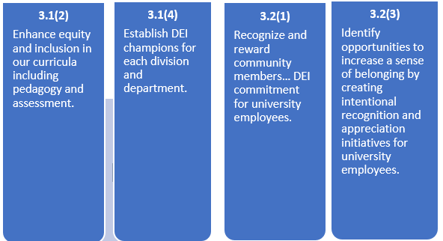

Discussion:

**3)** **Action Item** *(3 minutes)*

* Anticipated budget

**4)  Kelly Campbell - Steering Committee Liaisons Closing** *(3 minutes)*

**Future Meetings:**

* October 7 Admin rm 103
* October 28 Zoom
* November 18 Admin rm 103
* December 2 Zoom
* December 16 Admin rm 103