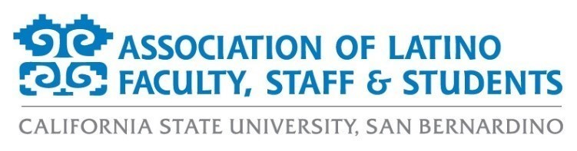

**ALFSS General Meeting Agenda**

**Wednesday, September 18, 2024**

**12:00 p.m. – 1:00 p.m.**

**Location: PL 4005**

|  |  |
| --- | --- |
| 1. **Call to Order**     1. 12:10pm 2. **Approval of Agenda**     1. 1st by Aurora Vilchis    2. 2nd by Ericka Saucedo    3. All in favor. Motion passes 3. **Approval of Meeting Minutes**     1. 1st by Ericka Saucedo    2. 2nd by Amber Adams    3. All in favor. Motion passes 4. **Introductions**    1. Welcome and greetings of both in person and zoom participants.       1. In attendance: Iwona, Ericka, Aurora, Monica, Amber, Ashley, Antonio, Carolina Macias, Carmen Beck, Jasmin Rodriguez 5. **Old Business**     1. Financial Report       1. Trust- $57,589.59       2. Scholarship- approx. $9,800       3. Donation- $22,776.31    2. Bienvenida Recap       1. Successful event, extra food at the end, great way to see everyone and reconnect, over 50 people in attendance, used as membership event. 6. **New Business**     1. Calendar of Events       1. Fall 2024          1. ALFSS Scholarship Lunch             1. Date: Tuesday, October 8, 12-2pm, SUN Conference Center             2. Chairs- Pamela and Aurora             3. Updates:   Bringing back from 2022 to recognize scholars and raise fundraising dollars  Selling tables and seats  $25 plate  $200 table  Recognizing 3 tamal award recipients- long term ALFSS members who have served on Board in previous years  Doris Selva  Olivia Rosas  Cesar Caballero  Recognizing 8 scholarship recipients  New this year, recognizing 1 ALFSS partner  Acto Latino   * + - 1. Cafecito with DHRE          1. Date TBD          2. Chair- Ashley and Antonio          3. Update:   Ashley will be reaching out to DHRE next week.   * + - 1. Dia de los Muertos          1. Date: Saturday, November 2 from 11am-3pm on Visual Arts Walk          2. Chair- Iwona          3. Updates:   First committee meeting occurred  Florkorio dancers booked  Preliminary schedule is out  RAFFMA is allowing decorations in the museum  Calaveras are out for decorating and are awaiting their return  Parking in Lot L is free  In negotiations to have food paid for the volunteers  Inviting clubs and orgs to come out   * + 1. Spring 2025        1. Spring Latinx Grad           1. Date: Saturday, May 10 at 10am in Arena           2. Chairs- Amber & Monica   1. Fundraising Events      1. Fall 2024         1. Escape Fundraiser **Rescheduled**            1. Monday, September 30, 7pm, Escape Craft Brewery on Nevada St.            2. Chairs- Aurora & Erika            3. Updates:   Date changed for the fires and smoke in the air  $5 per loteria card  Total of 5 rounds  All funds going to scholarships  Prize baskets will be given to winners  No proceeds from sale of alcohol, so everyone is welcome to come out and play loteria.   * + - 1. Pupusa Sale          1. Thursday, November 7, 11:30am, UH Plaza          2. Chair- Monica          3. Updates   Date has been moved to not conflict with other free food events.  1st right of refusal has been given by Yotie Eats  Looking for anyone interested in donating paper goods: forks, napkins, etc.   * + - 1. DDLM T-shirt Sale          1. Chair- Aurora          2. Updates:   For DDLM, AV is preparing a quote for Board to review for purchasing shirts.  Shirts will have ALFSS logo and calaveras.  Same design as previous years, but in a new color  Pre-orders will be available and ready for pick up on Nov. 2   * + 1. Spring 2025        1. 5k Run/ Walk           1. Chairs: Iwona and Brianna           2. Updates:   Planning will begin after DDLM   * + - 1. Pupusa Sale          1. Chair: Monica  1. **Officer Reports**     1. President       1. No report provided    2. President-Elect       1. Thank you for coming and hearing us out. Looking forward to welcoming new members    3. Executive Secretary       1. All board photos are on the website now       2. Updating website with all agendas and meeting minutes    4. Treasurer       1. No update    5. Director of Fundraising and Scholarship       1. No update    6. Director of Marketing       1. Website events have been updated. Registration links have been updated       2. Working on a new member marketing campaign    7. Director of Membership       1. Working on email list to update with current ALFSS members       2. Will be reaching out to past one-time ALFSS members for dues-renewal    8. Director of Programs       1. Working with program chairs to ensure they have all of the staffing needs met       2. Working on recruiting new members    9. Student Representative       1. No updates 2. **Discussion Topics**     1. No topics 3. **Adjournment**    1. 12:37pm | **Action Items:** |