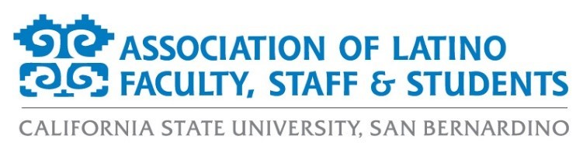

**ALFSS Board Agenda**

**Thursday, August 8, 2024**

**11:30 a.m. – 1:30 p.m.**

**Location: SUS 202**

1. **Call to order**
2. **Approval of Agenda**
3. **Approval of Retreat Minutes**
4. **Old Business**
   1. Membership (Brianna)
      1. Campaign and goals for the year
      2. Membership fee structure
   2. Bylaws Review (Pamela)
   3. Marketing (Amber)
      1. Purchase of Canva Pro subscription for ALFSS Marketing
      2. Newsletter platform
      3. MS Teams and Google Drive
   4. Logo and Association name change Ad Hoc Committee (Amber)
   5. Fall 2024 Confirmation
      1. Events (Antonio)
         1. Bienvenida
            1. Date: Wednesday, August 28 from 11:30am- 1:30pm in SUS Events Center
            2. Chair needed
         2. HHM Event(s)
            1. ALFSS Scholarship and Legacy Lunch

Date: Tuesday, October 8, 12-2pm, SUN Conference Center

Chairs: Aurora & Pamela

* + - * 1. Discussion of additional events

Latina authors discussion

Vendor fair with local Latina/o vendors

* + - 1. Dia de los Muertos
         1. Date: Saturday, November 2 (date needing verification)
         2. Chair: Iwona
      2. Fall Latinx Grad
         1. Discussion to keep or remove event
         2. Date: Saturday, December 7, 10am, SUN Conference Center
         3. Chairs: Aurora and Monica
    1. Fundraising (Aurora)
       1. Escape Fundraiser
          1. Monday, September 9, 7pm, Escape Craft Brewery on Nevada St.
          2. Chair: Aurora
       2. Pupusa Sale
          1. Thursday, October 17, 11:30am, Library Lawn
          2. Chair: Monica
       3. DDLM T-shirt Sale
          1. Chair: Aurora
       4. Crowdfunder
          1. Chair needed
  1. Spring 2025 Discussion
     1. Events (Antonio)
        1. PDC Latinx Grad
        2. Spring Latinx Grad
           1. Saturday, May 10, 10am, Arena
     2. Fundraising (Aurora)
        1. Bowling
        2. Cookie Co.
        3. 5k Run/Walk
           1. Chairs: Iwona and Brianna
        4. Pupusa Sale
           1. Chair: Monica
  2. Social Media Campaigns Discussion (Amber)
     1. Scholarship applications
     2. LGBTQ+ History
     3. Native/ Indigenous Heritage
     4. Black History
     5. Women’s History: Mujeres Mondays in March (Other ideas?)
     6. APIDA Heritage
     7. Arab American Heritage

1. **New Business** 
   1. Agenda for general meeting (Pamela)
   2. Board polo & nametag purchase (Aurora)
   3. ALFSS slogan (Amber)
   4. FSSA Update (Pamela)
   5. Storage (Pamela)
2. **Discussion Topics**
3. **Adjournment**