Table of Contents
Hazard Communication Program 2
Regulatory Authority 2
Administering Agency 2
Environmental Health and Safety Policy 2
Purpose 2
Scope 2
Responsibilities 3
Environmental Health and Safety Department 3
Departments 3
Employee 3
Chemical Inventory 4
General Requirements 4
Consumer Products 4
Labeling 4
Labeled/Unlabeled Pipes (if applicable) 5
Hazardous Non-Routine Task 5
Safety Data Sheets (SDS’s) 5
Employee Information and Training 6
Trade Secrets 7
Access to Hazardous Areas 7
Informing Contractors 7
Record Keeping 8
Emergency Procedures 8
Appendix A: GHS Pictograms and Labeling 9
Appendix B: Secondary Container Labeling 10
Appendix C: Hazardous Waste label 11

Hazard Communication Program

Regulatory Authority
Title 8, California Code of Regulations, Section 5194.

Administering Agency
California Occupational Safety and Health Agency (CAL/OSHA)

Environmental Health and Safety Policy
It is the policy of California State University, San Bernardino to maintain, insofar as it is reasonably within the control of the University to do so, a campus environment for students, faculty, staff and visitors that will not adversely affect their health, safety, and surrounding environment or subject them to available risks of accidental injury or illness.
All employees who use or may be exposed to potentially hazardous substances or harmful physical agents shall be informed about the hazard of those substances or physical agents. These employees shall be trained in the precautions to prevent exposure and what to do if they are accidentally exposed.

Purpose
Hazardous substances in the workplace, in some forms and concentrations, pose potential health hazards to employees who are exposed to these substances. Departments and employees have a right and a need to know the properties and potential hazards of substances to which they may be exposed. Such knowledge is essential in reducing the incidence of occupational disease. This program will improve the detection, treatment, and prevention of occupational illness and disease and support workers' right to know.
This program is also intended to ensure that departments provide their employees with training on how to avoid exposure to hazardous substances and what to do if they are accidentally exposed to such substances.

Scope
This program shall apply to all departments that use, handle, or store hazardous substances.
This program shall apply to any hazardous substance, which is known to be present in the workplace in such a manner that employees may be exposed under normal conditions of use or in a foreseeable emergency.
This program does not apply to:
  - Any hazardous waste regulated by the Solid Waste Disposal Act, amended by the Resource Conservation and Recovery Act of 1976;
  - Tobacco or tobacco products;
  - Wood or wood products;
  - Articles;
  - Food, drugs, or cosmetics intended for personal consumption by employees while in the workplace;
  - Any consumer product packaged for distribution, to, and used by the general public, provided the exposure to university employees is significantly greater than that of the general public.

Responsibilities

Environmental Health and Safety Department
- Develop, implement, and monitor the Hazard Communication Program (HCP).
- Provide consultation to Deans, Directors, Chairpersons and Designated Safety Coordinators (DSC) regarding HCP compliance.
- Assist Departments in complying with HCP requirements including labeling, Safety Data Sheet (SDS), employee information and training, and centralized record keeping.
- Maintain centralized inventory of hazardous substances and SDS on campus.
- EHS will conduct periodic program review at least once every three years.

Departments
- Develop and maintain written departmental procedures to ensure effective compliance with the HCP.
- Ensure that all requirements of the HCP have been met before employees are exposed to hazardous substances under normal conditions of use or in a foreseeable emergency.
- Develop and maintain an inventory of hazardous substances present in all work areas within departments.
- Maintain a file of SDS's in a location readily accessible to department employees.
- Provide employees with information and training on hazardous substances in their work area at the time of their initial assignment, and whenever a new hazard is introduced in their work area.
- Provide the EH&S Department a copy of hazardous substances inventory, SDS, and training records for a centralized file.

Employee
- Each employee assigned to work with a hazardous substance shall read and comply with all HCP procedures (written or oral) while performing assigned duties.
- Each employee will attend established training sessions and be expected to understand and comply with all applicable HCP requirements. Failure to comply with established HCP guidelines may be reflected in performance evaluations and may lead to disciplinary action.
- Every employee is responsible for asking questions of their supervisors when there is concern about an unknown or potentially hazardous substance.
- Employees are responsible in conducting themselves in a manner, which promotes safety and avoids safe or unhealthful conditions.

Chemical Inventory

General Requirements
All departments that use, handle or store hazardous chemicals must maintain an inventory of the hazardous chemicals present in their work areas at all times and regularly updated.

Consumer Products
Consumer products must be included in the chemical inventory if the employee exposure to the product is significantly greater than the consumer exposure occurring during the principal consumer use of the product. However, certain minimal inventory thresholds are required for other reporting agencies such as Certified Unified Program Agency (CUPA).

Labeling
Every container of a hazardous chemical, except containers that will contain chemicals for immediate use, must be labeled, tagged, or marked to identify the substance and appropriate hazard warnings.
Each department shall ensure that each container of hazardous substances in the workplace is labeled, tagged or marked with the following information:
  - Identification of the hazardous substance(s) contained therein;
  - Pictogram(s) Appendix A;
  - Signal word;
  - Appropriate hazard warnings;
  - Precautionary statement(s); and
  - Name and address of manufacturer, importer or other responsible party.
All secondary containers of hazardous materials shall be labeled with the approved secondary container labeling method identified in Appendix B.
Employees shall not remove or deface existing labels on incoming containers of hazardous substances.
Hazardous waste container must be labeled with and approved hazardous waste label with the following information:
- The date upon which each period of accumulation begins must be clearly marked and visible for inspection on each accumulation unit.
- While being accumulated on site, each generator tank or container must be labeled or clearly marked with the words, "Hazardous Waste." Appendix C
- Each container and portable tank in which hazardous waste is accumulated must be labeled with the following information:
  - Composition and physical state of the waste;
  - Statement or statements that call attention to the particular hazardous properties of the waste (e.g. flammable, reactive etc)
  - Name and address of the generator.
- Each hazardous waste container must be stored in a secondary container.

Labeled/Unlabeled Pipes (if applicable)
Aboveground pipes transporting hazardous substances (gases, vapors, liquids, semi-liquids, or plastics) are identified in accordance with 8 CCR, Section 3321, “Identification of Piping.” Other aboveground pipes that do not contain hazardous substances but may have associated hazards if disturbed or cut (e.g., steam lines, oxygen lines) are addressed as follows:
- Before employees enter the area and initiate work, Environmental Health and Safety will inform them of:
  - The location of the pipe or piping system or other known safety hazard
  - The substance in the pipe
  - Potential hazards
  - Safety precautions

Hazardous Non-Routine Task
Periodically, employees are required to perform hazardous non-routine tasks. Prior to starting work on such projects, affected employees will be given information by their Manager or Supervisor on hazards to which they may be exposed during such an activity.
This information will cover:
- Specific hazards
- Measures the department has taken to reduce the risk of these hazards, such as providing ventilation, ensuring the presence of another employee, providing a respiratory protection program, and establishing emergency procedures.
- Required protective/safety measures

Safety Data Sheets (SDS’s)
- Each SDS shall be in English and shall contain specific information:
- Section 1: Identification of chemical and common name(s) of all ingredients that present
health hazards
- Section 2: Hazard identification
- Section 3: Composition/Information on ingredients
- Section 4: First aid measures
- Section 5: Firefighting measures
- Section 6: Accidental release measures
- Section 7: Handling and storage
- Section 8: Exposure controls/ person protection
- Section 9: Physical and chemical properties
- Section 10: Stability and reactivity
- Section 11: Toxicological information
- Section 12: Ecological information
- Section 13: Disposal considerations
- Section 14: Transport information
- Section 15: Regulatory information
- Section 16: Other information, including date of preparation or last revision
- Departments shall maintain an SDS for each hazardous substance used in the department, and perform an annual audit of their SDS files.
- Departments shall ensure that this information is readily accessible during each work shift to employees when they are in their work areas.
- The EH&S Department shall maintain a master file of hazardous substance inventory and SDS's on campus.
- If an SDS is not provided by the manufacturer, the ordering department will contact EH&S office who shall:
  - Send a written request to the manufacturer,
  - In the event one is still not received from the manufacturer, EH&S shall notify the Director of Industrial Relations.

Employee Information and Training
Departments shall provide employees with information and training on hazardous substances in their work area at the time of their initial assignment and whenever a new hazard is introduced in their work area.
Departments shall furnish employees with an explanation of what the SDS is and of the contents of the SDS for any hazardous substance to which the employees are exposed, either in written form or through training programs.
When training employees who may be exposed to hazardous substances, the department shall ensure that each of the following hazard communication training requirements are covered.
- When training employees who may be exposed to hazardous substances, each department shall ensure the following information is explained as outlined in the SDS:
  - Any health hazards associated with the use of this substance or mixture,
  - Proper precautions for handling, necessary personal protective equipment or other safety precautions necessary to prevent or minimize exposure to the hazardous substance,
  - Emergency procedures for spills, fire, disposal, and first aid. The information may relate to an entire class of hazardous substances to the extent appropriate and related to the job.
  - Significant revisions in the SDS shall be provided to all employees.
- Each department shall inform employees of their right:
  - To personally receive information regarding hazardous substances to which they may be exposed.
  - For their physician or collective bargaining agent to receive such information.
  - Against dismissal or other discrimination due to the employee's exercise of their rights afforded by this law.
- Departments shall ensure employees are informed of:
  - Requirements of the HCP.
  - Any operations in their work area where hazardous substances are present.
  - Location and availability of the written HCP.
- Departments shall ensure that employees are trained in:
  - Methods and observations that may be used to detect the presence or release of hazardous substance in the work area.
  - Physical and health hazards of the substances in the work area and the measures they can take to protect themselves from these hazards. These measures shall include specific procedures the department has implemented to protect employees from exposure to hazardous substances.
  - Details of the HCP including an explanation of the labeling system, the MSDS, and how employees can obtain and use the appropriate hazard information.
BECAUSE THE REQUIRED HAZCOM STANDARD HAS BEEN REVISED TO ALIGN WITH UNITED NATIONS GLOBALLY HARMONIZED SYSTEM OF CLASSIFICATION AND LABELING OF CHEMICALS (GHS), ALL EMPLOYESS ARE REQUIRED TO BE TRAINED ON THE NEW LABELING AND SDS REQUIREMENTS BY DECEMBER 1, 2013 (SEE APPENDIX C – OSHA® FACT SHEET). ALL EMPLOYERS ARE REQUIRED TO FULLY IMPLEMENT THE NEW HAZCOM STANDARD BY JUNE 1, 2016.

Trade Secrets
Under certain circumstances, the manufacturer may withhold the specific chemical identity, including the chemical name and other specific identification of a hazardous substance, from the SDS. However, when a treating physician determines that a medical emergency exists and the chemical identity is required for first-aid treatment, the manufacturer must disclose the trade secret information to the physician.

Access to Hazardous Areas
Due to the potential for exposure to hazardous substances, designated areas on campus shall have limited access to University employees, students and/or outside personnel.
Hazardous areas shall be identified by signage on the location door. A contact person(s) shall be identified along with their phone number.
Work orders shall indicate any work that is scheduled for any hazardous location.
During normal business hours, and as appropriate for the hazard level of the work area, Facilities Management/Responsible Party will notify the contact person that work has been scheduled in a room under their supervision. The work area (drains, fume hoods, cabinets, etc.) must be cleared of all hazardous chemicals.
Work will not begin until the area is clear of hazardous materials. If there is any doubt regarding the safety of the area, EHS or the appropriate knowledgeable party shall be notified.
If the area cannot be cleared of hazardous material, appropriate personal protection shall be worn to avoid whatever hazard is involved.

Informing Contractors
Facilities Planning, Design and Constriction is responsible for informing any contractors and sub-contractors with employees working on campus of the hazardous substances to which their employees may be exposed while performing their work, as well as the hazardous labeling system used on campus.
This information shall be provided to the contractor in the bid documents and during the pre-construction meeting. The SDS for any hazardous material that may be encountered will be provided to the contractor at that time.
EHS is responsible for providing this information Facilities Planning, Design and Constriction upon request.
EHS will investigate options to minimize possible exposure to hazardous materials by the contractor and shall inform construction management of these measures.
Facilities Management is also responsible for obtaining copies of the SDS for any hazardous substance that the contractor is bringing into the workplace. The contractor shall provide this information to Construction Management prior to the start of work.

Record Keeping
Training must be documented and records must be retained for at least three years. The Illness & Injury Prevention Program Safety Training Attendance Record or its equal may be used to document instructor-led training. At a minimum, the following information must be documented:
- Name of individual(s) trained;
- Name of individual(s) providing training for instructor-led courses;
- Date of training; and
- Brief description of training topics covered.
Computer-based training provided in the campus Learning Management System will be documented electronically.

Emergency Procedures
Employees shall follow emergency procedures covered in their department-specific Emergency Action Plan and Injury and Illness Prevention Program. Emergency response procedures are also covered in the SDSs, labels, and CSUSB Emergency Management and Business Continuity Preparedness Reference Guide.

Appendix A: GHS Pictograms and Labeling

GHS Hazard Pictograms
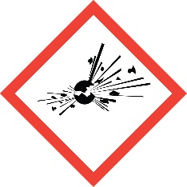 | 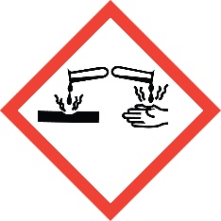 | 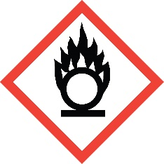
Exploding Bomb  •Explosives  •Self-reactives  •Organic peroxides | Corrosion  •Skin corrosion/burns  •Eye damage  •Corrosive to metals | Flame Over Circle  •Oxidizing gases  •Oxidizing liquids  •Oxidizing solids
 | 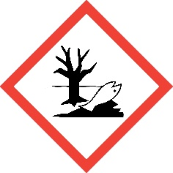 | 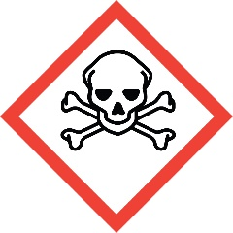
Gas Cylinder  •Gases under pressure | Environment  •Aquatic toxicity | Skull & Crossbones  •Acute toxicity (fatal or  toxic)
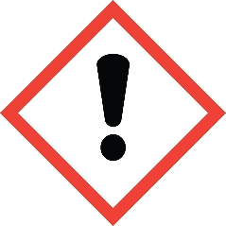 | 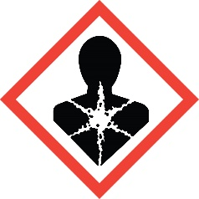 | 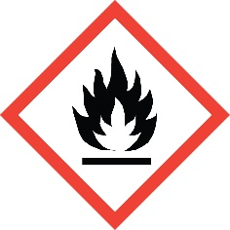
Exclamation Mark  •Irritant (eye & skin)  •Skin sensitizer  •Acute toxicity  •Narcotic effects  •Respiratory tract irritant  •Hazardous to ozone layer (non-mandatory) | Health Hazard  •Carcinogen  •Mutagenicity  •Reproductive toxicity  •Respiratory sensitizer  •Target organ toxicity  •Aspiration toxicity | Flame  •Flammables  •Pyrophorics  •Self-heating  •Emits flammable gas  •Self-reactives  •Organic peroxides
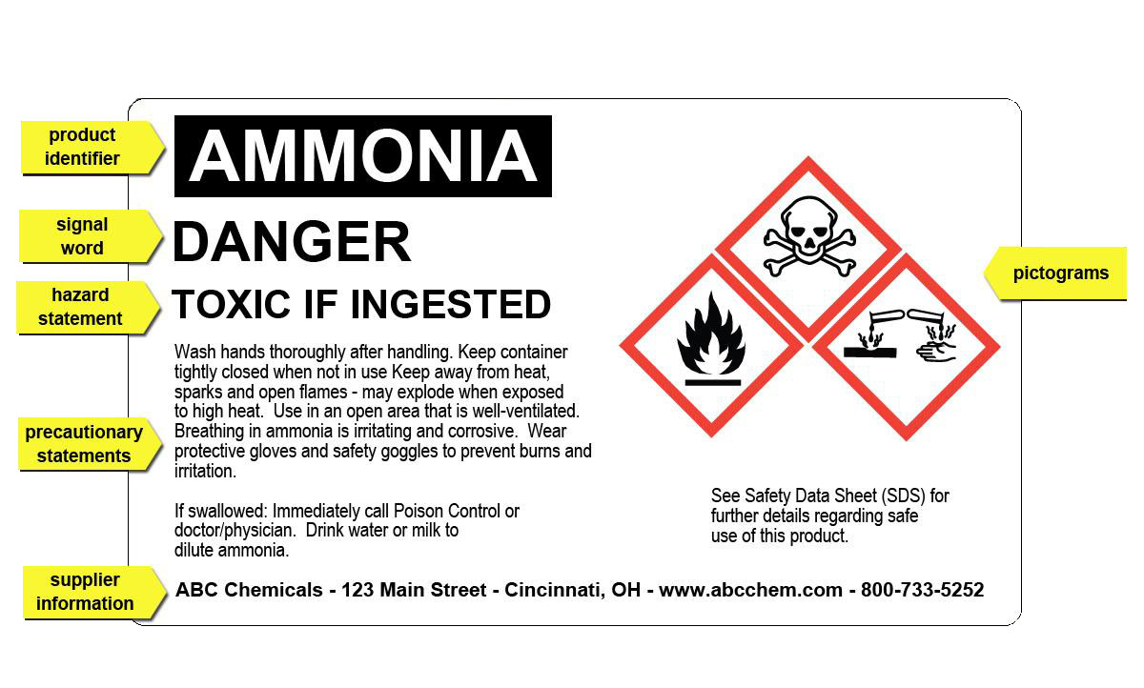
Components of a GHS Label
- Product Identifier
- Signal word
- Hazard Statement
- Precautionary statement
- Supplier information
- pictograms

Appendix B: Secondary Container Labeling

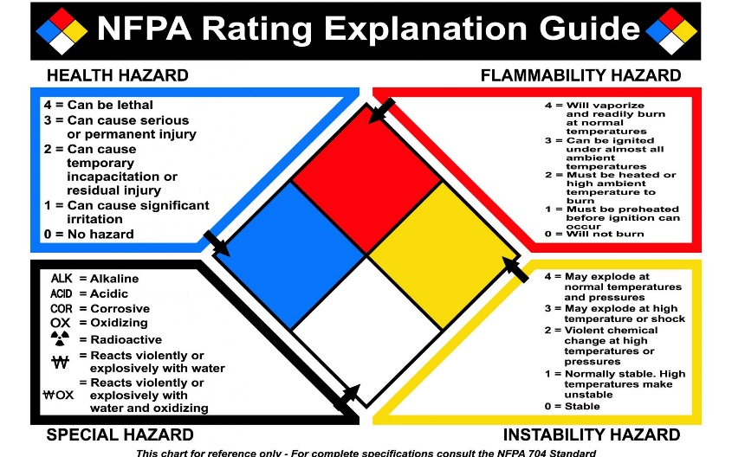

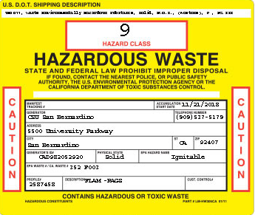
Appendix C: Hazardous Waste label
Important parts that need to be completed:
- Hazard class
- Generator
- Address
- City, State and Zip
- Generator ID#
- Physical State
- Hazardous constituents ( may be on a separate piece of paper attached to container)

