The Adaptation of Online Project-based Learning in Computer Engineering Education Settings
Yunfei Hou, Fadi Muheidat, Amir Ghasemkhani, Qingquan Sun,
Haiyan Qiao, Miranda McIntyre and Montgomery Van Wart
California State University San Bernardino, San Bernardino CA 92407, USA
Abstract. While many universities offered some online courses in computer engineering prior to the COVID-19 pandemic, few offered project-based courses in a fully virtual mode. This has changed with pandemic-related restrictions. When converting to an online-only mode, active-learning projects and lab components of computer engineering courses pose additional challenges because they require face-to-face interaction and specialized equipment. In this paper, we present how we adapted a year-long capstone course to be fully online at a public university in California, U.S., and report our findings based on students’ perceptions. Our major findings are: 1) students’ satisfaction rates of online courses improved over the one year of online-only learning, and 2) students tended to prefer synchronous lectures, but the difference in preference between synchronous vs. asynchronous teaching was not significant.
- Introduction
The coronavirus pandemic has challenged many aspects of the educational system. Moving from face-to-face instruction to online learning has produced questions about the long-held, fundamental ideas about instruction, attendance, evaluation, the role of technology and human interactions, etc. Online learning offers valuable advantages compared to face-to-face such as time and space flexibility, long-term access to written and recorded lectures, opportunities for self-regulated learning, and efficient programmed learning. However, adapting project-based courses (e.g., computer engineering design capstone course) to an online learning structure requires careful planning and teaching presence to support successful learning outcomes such as teamwork skills, effective communication, self-directed learning of new knowledge, and the ability to apply engineering design solutions need to be satisfied.
The goal of this paper is to summarize and discuss the lessons learned from teaching project-based courses that are fully online. The results can help better design computer engineering courses in remote or hybrid learning modalities after the COVID-19 pandemic. We will present the implementation of project-based learning in a one-year-long capstone course for undergraduate computer engineering students. We will discuss the pedagogical considerations based on the student outcomes mandated by the Accreditation Board for Engineering and Technology’s Engineering Accreditation Commission (ABET EAC).
The paper consists of two parts: 1) how we transformed the design of project-based learning courses to be fully online, and 2) an analysis of the students’ perceptions of online learning. In order to measure students’ perceptions regarding online learning experiences and learning outcomes, we conducted two surveys in June 2020 and March 2021. The surveys covered both the first and last terms that the university moved to fully online instruction. This allowed us not only to capture students’ opinions but also investigate how their opinions and expectations evolved during the pandemic.
- Related Work
Computer science and engineering curriculums include both theory and hands-on skills. To accomplish the important latter goal, schools set aside lab components for most courses. In those courses, the faculty set aside time to assist students in understanding the concepts through hands-on experience, either by simulation or experimental boards and systems [1]. Project-based learning relates to learning theories, cooperative learning, acquiring knowledge, thinking process, and problem-solving skills. It is learner-centered, makes them curious and enthusiastic about exploring more. Most students are keen to learn by utilizing real tools rather than just covering theoretical concepts with pen and paper [2]. Project-based learning can be applied in particular courses or throughout a curriculum. It may be coupled with traditional teaching or implemented through individual or small group settings, and may last from a few weeks to a year [1]. Computer science and engineering students also benefit from the hardware experience to establish a clear picture of the relevant relationship among many hardware components. Through hands-on activities, the students can quickly grasp the concepts of computer operations, examine the CPU structure while executing programs, and acquire the ability to adjust expert skills in their careers [3]. The practical activity can also make them enjoy learning [2]. Learning-by-doing is a learning paradigm where students tend to be more engaged by hands-on activities based on physical lab components than simulation-only activities. [3]. Some [4] went one step further by proposing that we move to project-based learning and allow the students to design and implement their projects in alignment with the assignment objectives and goals, rather than the traditional guided lab assignment. In [4], the authors found that the “create your project” was more enjoyable and useful by engaging their personal interest. The ultimate goal is to establish a good learning environment for students to gain experience in developing projects. In this paper, we acknowledge the importance of hands-on and project-based courses. Unlike much of the previous literature, however, we are interested in the students and faculty perspectives on transforming these assignments into an online format.
- The Engineering Design Course
At the computer science and engineering program used in this study, the engineering design capstone course is offered through two consecutive semesters and entitled “Computer Engineering Design”. These courses include a lecture section where students are introduced to the engineering design process, a lab section where students practice their knowledge of computer engineering concepts through empirical lab assignments, and a final project where students work in teams for two semesters. The final projects are defined based on real-world engineering applications which require careful system architectural design and evaluation, concurrent hardware and software design, system integration, testing and validation. The final student products are a working prototype and project documentation. The computer engineering capstone course targets five different ABET student learning outcomes [5] including: 1) an ability to apply engineering design to produce solutions that meet specified needs with consideration of public health, safety and welfare, as well as global, cultural, social, environmental, and economic factors; 2) an ability to communicate effectively with a range of audiences; 3) an ability to recognize ethical and professional responsibilities in engineering situations and make informed judgments, which must consider the impact of engineering solutions in global, economic, environmental, and societal contexts; 4) an ability to function effectively on a team whose members together provide leadership, create a collaborative and inclusive environment, establish goals, plan tasks, and meet objectives; and 5) an ability to acquire and apply new knowledge as needed, using appropriate learning strategies. In what follows, we present the implemented strategies for this year-long computer engineering capstone course to enhance students’ learning in a virtual environment.
Logistical support: Due to the COVID-19 pandemic, students did not have access to face-to-face lab instructions and lab equipment. The university of this study was fully online from March 2020 to August 2021. To alleviate the logistical hurdles of the lab assignments, we offered no-cost lab supplies to students during the pandemic on an as-needed basis. First, a list of required equipment for all the lab assignments was provided to students at the beginning of the semester. Then, they were asked to notify the instructors with a list of items they needed to be mailed to them from the department supply. As a result, all students had access to the necessary equipment for at-home lab assignments during online synchronous sessions.
Flexible project selection: The scope of projects for the computer engineering capstone course revolves around the computer engineering concepts gained from undergraduate courses. In the past, the selected software-hardware co-design projects required some level of face-to-face interactions between team members. This posed a challenge during the pandemic since the students could not meet in-person due to health safety issues. To address this challenge, we offered software-only projects (e.g., facial recognition to match photos in the database) by relaxing the hardware component integration. The focus was on software modules which can be integrated into hardware components in different design problems (e.g., facial recognition module for unlocking a door), see Fig.1. As a result, students had two options for selecting their final projects: hardware-software or software only.
Facilitating virtual teamwork activities: The lecture and lab sessions of the computer engineering capstone course were held synchronously through Zoom meetings. Students were given in-class and asynchronous assignments alongside their final project to work in teams. The main challenge was to provide a suitable virtual environment for teams to work and manage their tasks similar to a face-to-face environment. In this regard, facilitating virtual teamwork activities to enhance the students' learning process is critical. Students were introduced to strategies for effective teamwork through a lecture on team dynamics, structures, ethics, and conflict management at the beginning of the first semester. Then, team members were asked to define their own ground rules for their teams. To simulate face-to-face interactions, Zoom breakout rooms were utilized to put student in private team sessions while instructor support is provided.
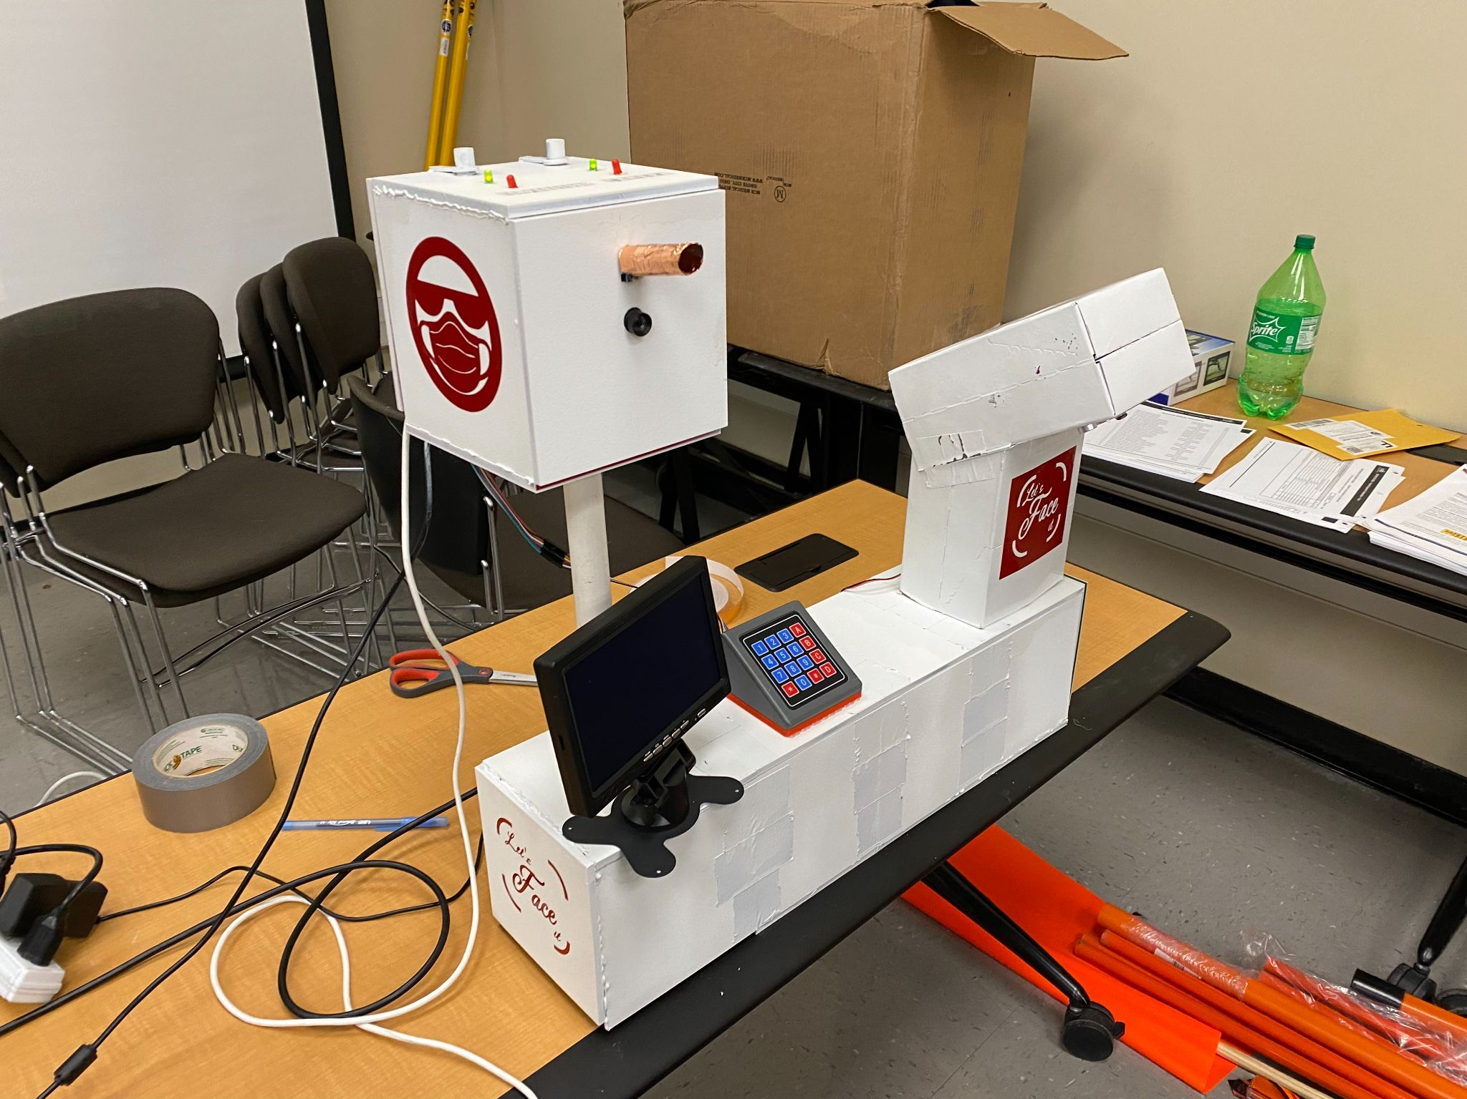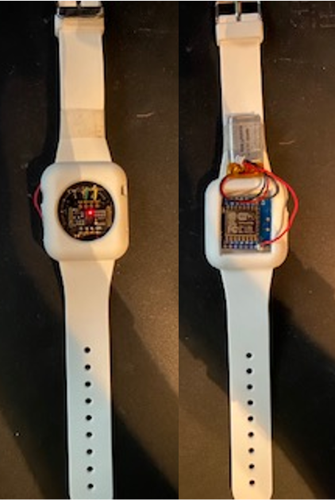
Fig. 1. Sample Projects. COVID-19 Face mask recognition lock (left). A door lock fixed with a keypad and face scanner. To ensure that the person accessing the door is "fit" to work, an apparatus connected requires the face to be scanned to see if guests are wearing masks properly. It also checks the temperature and has a hand sanitizer dispenser. Vitals on the Go (right). A wristband with NodeMCU Esp8266 development board to communicate with an application in the user’s cell phone. This design tracks and monitors a person’s health indicators such as temperature and heart beat and notifies the user of any unusual change in the health conditions.

Regular instructor-student meetings: In a virtual learning environment, a lack of face-to-face interaction can make it difficult for team members to receive adequate feedback from instructors. When left on their own, virtual team members are more likely to get into ambiguity about their roles, project outcomes, expectations, etc. Therefore, regular instructor-team meetings are a powerful strategy that enables instructors to build a relationship with students in a virtual environment, address their needs, set clear expectations, and help students to achieve their best performance. Specifically, instructors required regular updates about the progress of each team and set clear expectations and goals for each team’s project outcomes. Additionally, instructors monitored each student’s progress and provided necessary guidance to students. In sum, students had many opportunities to seek clarification or assistance with their projects and assignments during meetings, as well as virtual office hours, email etc.
Taking Advantage of new online learning platforms: The main challenge with online learning for computer engineering courses is to provide hands-on experience for hardware-related assignments. To address this issue, online learning platforms such as Tinkercad were leveraged to create models of electronic circuits with embedded microcontrollers (e.g., Arduinos). Students developed their codes for the microcontrollers on a web-based interface, practiced the correct wiring of different components, and tracked the real-time results. Subsequently, students were given an option to work and submit their hardware-related assignments using the online platforms. Moreover, other readily accessible online design and prototyping tools (e.g., Figma) were introduced to design UI/UX of the final project prototype.
Adjusting course contents for online learning: The course content for the computer engineering capstone course was prepared based on the pre-selected projects for the year. The main theme was about cyber physical system (CPS) applications such as building a parking lot monitoring system on a college campus with IoT sensors and surveillance cameras, and building a smart home appliance with sensing, control, and communication capabilities. In this regard, lectures were mainly focused on detailed implementation of CPS’ components including control, sensing and communication sub-systems since students need to have these features in their projects. However, it is challenging to cover the detailed implementation of the physical components for CPS applications in a virtual environment which usually requires face-to-face interactions and specialized equipment. To tackle these challenges, instructors prepared the course content with more emphasis on the data processing/analysis, UI/UX design, and app development components (e.g., flutter app development, python GUI, etc.) and relaxed the requirements related to face-to-face meetings, prototype packaging/casing, and hardware integration. In addition, asynchronous tutorials were prepared for the important hardware related topics to cover the detailed design of physical components (e.g., wireless communication protocol with Node MCU and Raspberry Pi). Finally, due to time and space flexibility in the virtual environment, résumé and job-interview workshops were also offered as part of the course by inviting alumni speakers to prepare the students for the future job-hunting process.
- Survey Results
Two surveys were created to measure STEM students’ perceptions of online learning. They were conducted in the Spring 2020 [6] and Spring 2021 terms when the university was in the first and last mandatory online teaching terms. The university in this study is the region’s largest public, comprehensive university, with a student population over 20,000. Hispanic minorities make up over half of the student population. 58% of undergraduate students receive financial aid (Pell Grant recipients). The surveys were sent to the School of Computer Science and Engineering with about 900 major students. We received a total of 179 and 156 responses in Spring 2020 and Spring 2021, respectively. In the Spring 2021 sub-sample, we had 86.5% male (13.5% female), 42.9% Hispanic, and the average student age was 24.8 years (range = 18 to 43). Major results of this study can be summarized into three categories: Teaching Presence, Course Format and Online Modality.
  - Teaching Presence
Teaching Presence refers to students’ perceptions about the quality of lectures, as well as directions and feedback received from instructors. To assess student perceptions, we asked about their satisfaction with online courses in general and with project-based courses specifically, and then compared the results from the Spring 2020 and Spring 2021 terms.
The empirical data indicated that the overall satisfaction rate of online teaching had improved over the past year during the COVID-19 disruptions (refer to Fig.2). Students that indicated they were satisfied (including both extremely and somewhat satisfied categories) with online courses increased from 43.5% in Spring 2020 to 48.1% in Spring 2021. While the percentage of dissatisfied respondents remained roughly the same (29.9% in Spring 2021, and 29.5% in Spring 2021), it is worth noting an encouraging trend at the two ends of spectrum in Fig. 2: Students that were Extremely Dissatisfied dropped by 3.8%, and student that were Extremely Satisfied increased by 10.9%. This confirmed our observation that both students and faculty have better adapted to the online learning environment.
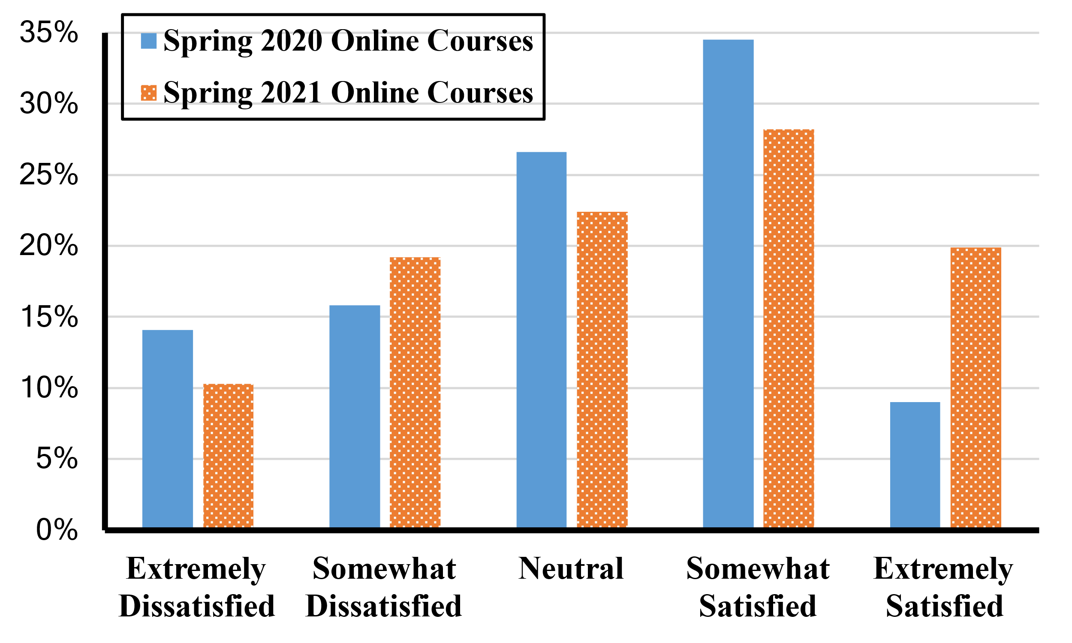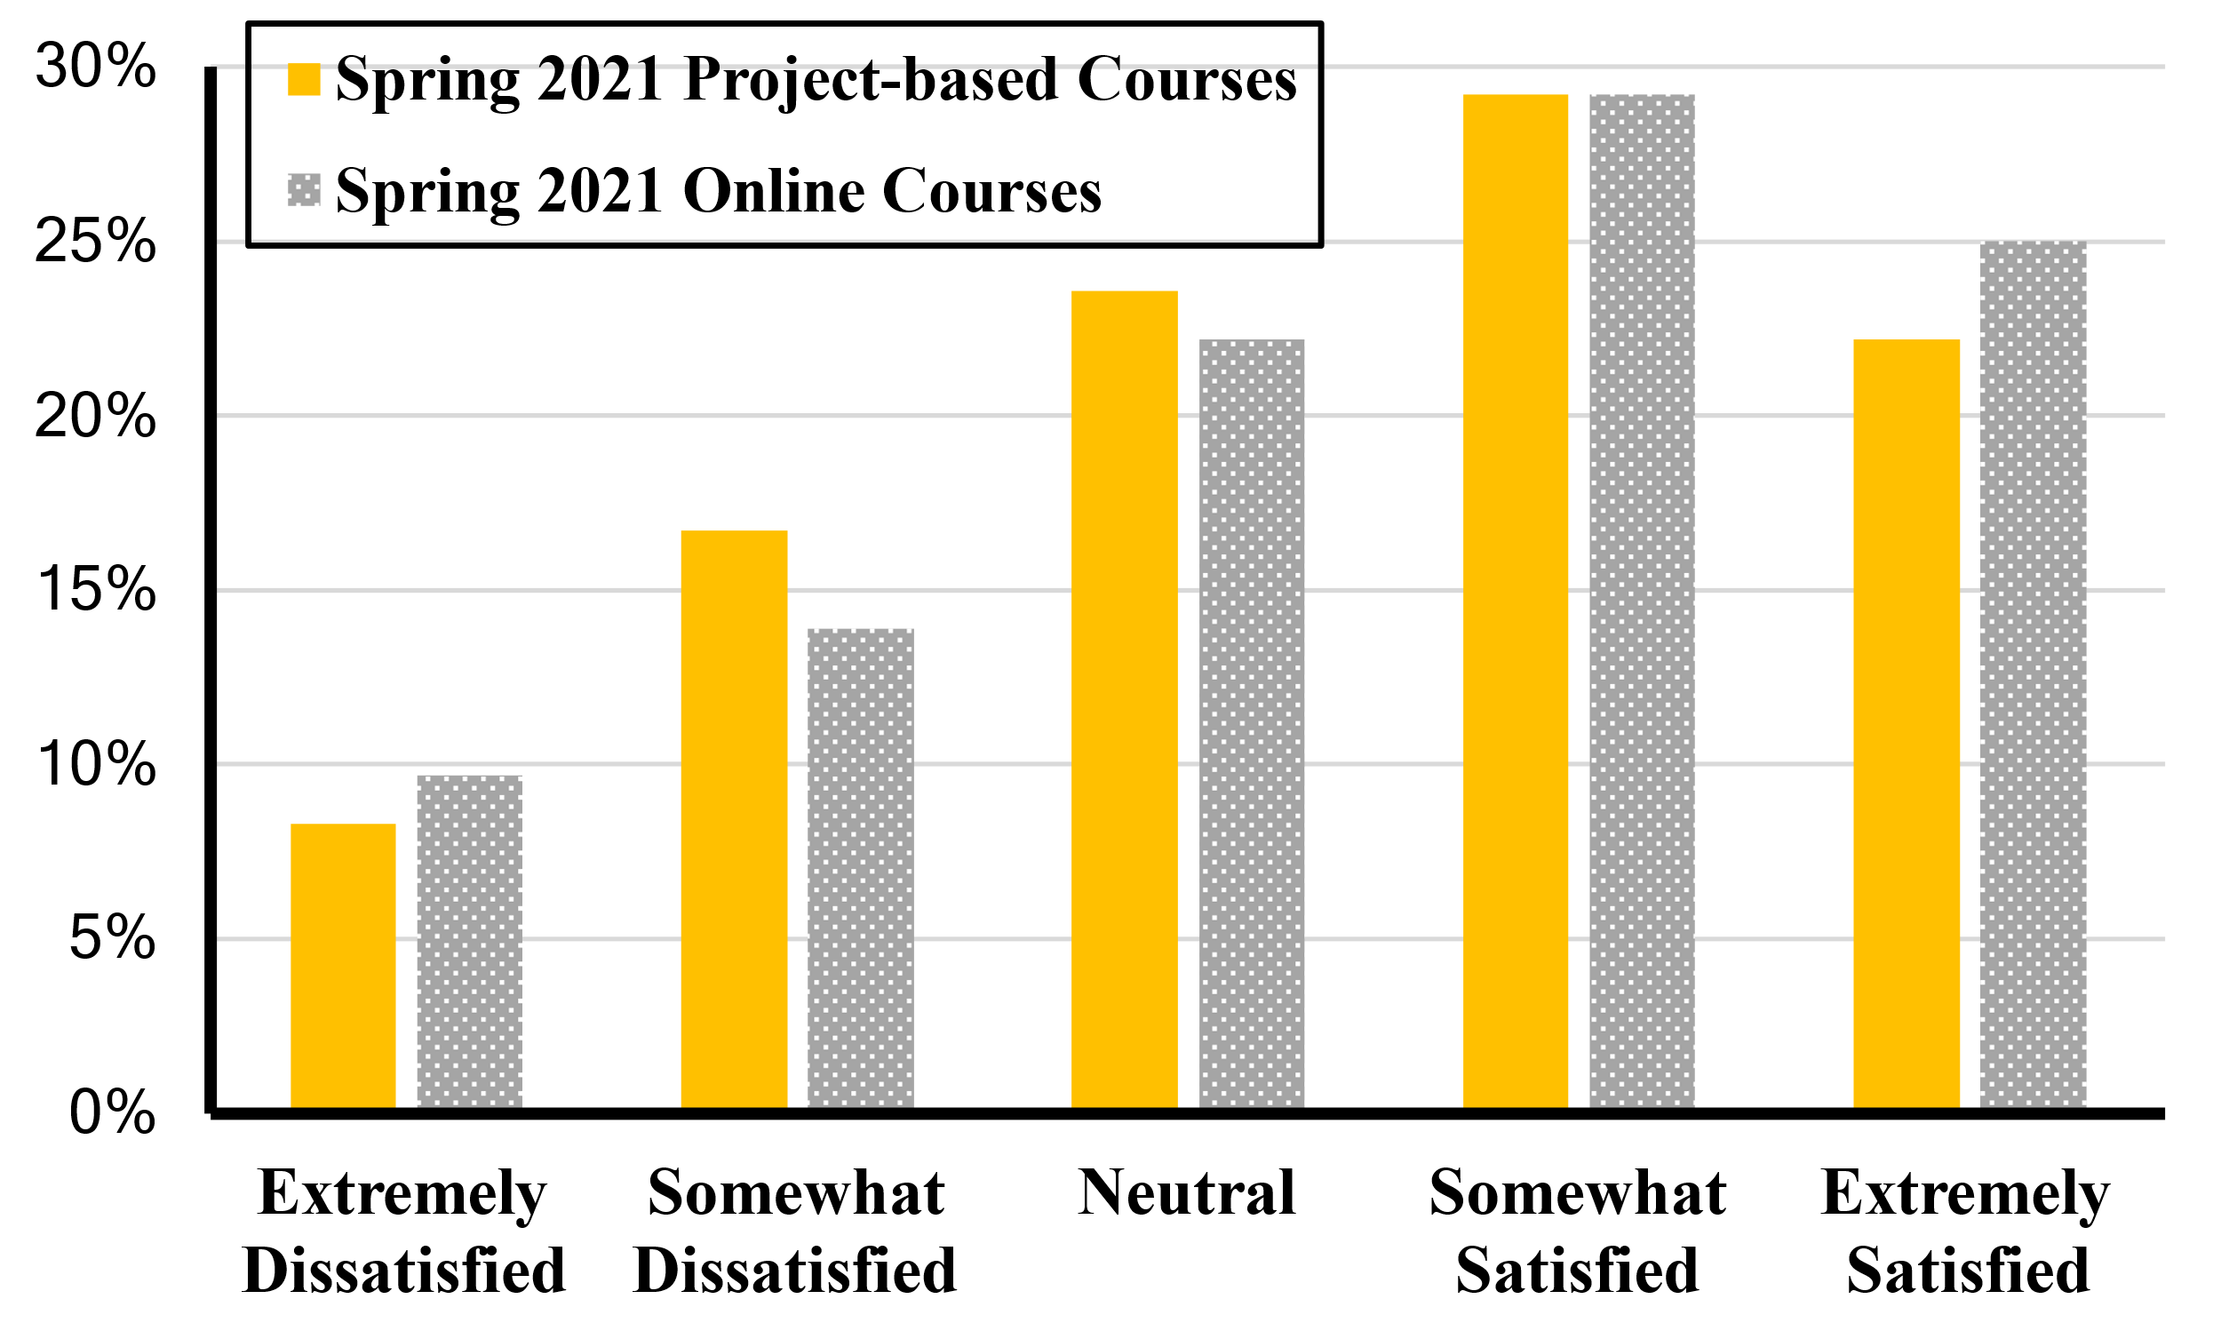
Fig. 2. Question: Overall, how satisfied are you with your online courses? | Fig. 3. Question: Overall, how satisfied are you with your online project-based courses?

In the Spring 2021 survey, we specifically asked students how satisfied they are with the project-based courses. Among the 156 respondents in the Spring 2021 survey, 72 of them were taking online project-based courses, i.e., the Engineering Design courses and Senior Design courses. We compared these 72 students’ perceptions of project-based courses with their overall online courses in Fig. 3, which indicated slightly less satisfaction on project-based course. In the case of project-based courses, 51.4% of the students indicated that they were satisfied, whereas 54.2% students were satisfied with online courses in general. There were also more percentages of respondents that were dissatisfied with project-based courses (i.e., 25%) when compared to online courses in general (i.e., 23.6%). The results confirmed our observation that students were not keen on online project-based courses, due to the difficulties on team collaboration and the lack of equipment and facilities.
  - Course Format
In the online learning environment, we were interested in understanding students’ preferences between synchronous and asynchronous lectures, differences in the composition of lecture time, and grading policies. The past year provides a special opportunity to experiment with different course formats which can help guide online teaching after the pandemic.
When considering the preference regarding synchronous lectures (i.e., live virtual class meetings) vs. asynchronous lectures (i.e., pre-recorded), the results were slightly favored asynchronous. In Spring 2020, 47.5% of respondents preferred asynchronous lecture; after one year of fully online learning, this number increased to 50.7% in Spring 2021. In comparison, 41.3% of respondents preferred synchronous lectures in Spring 2020, and that rose slightly to 42.3% in Spring 2021. See Figure 4. There was no significant correlation by class standing (the logistic regression p≥.231).
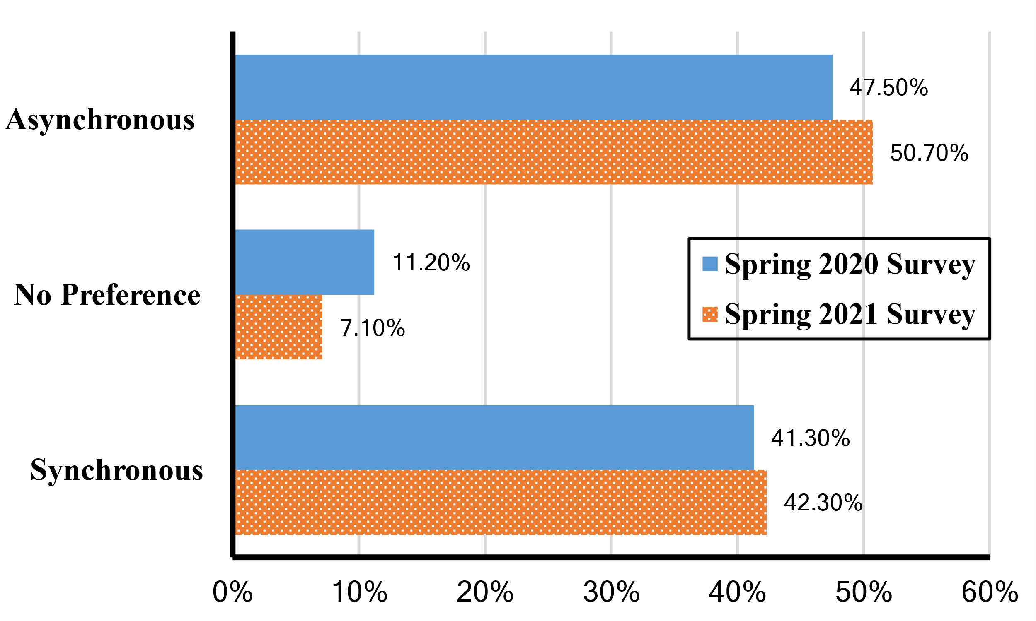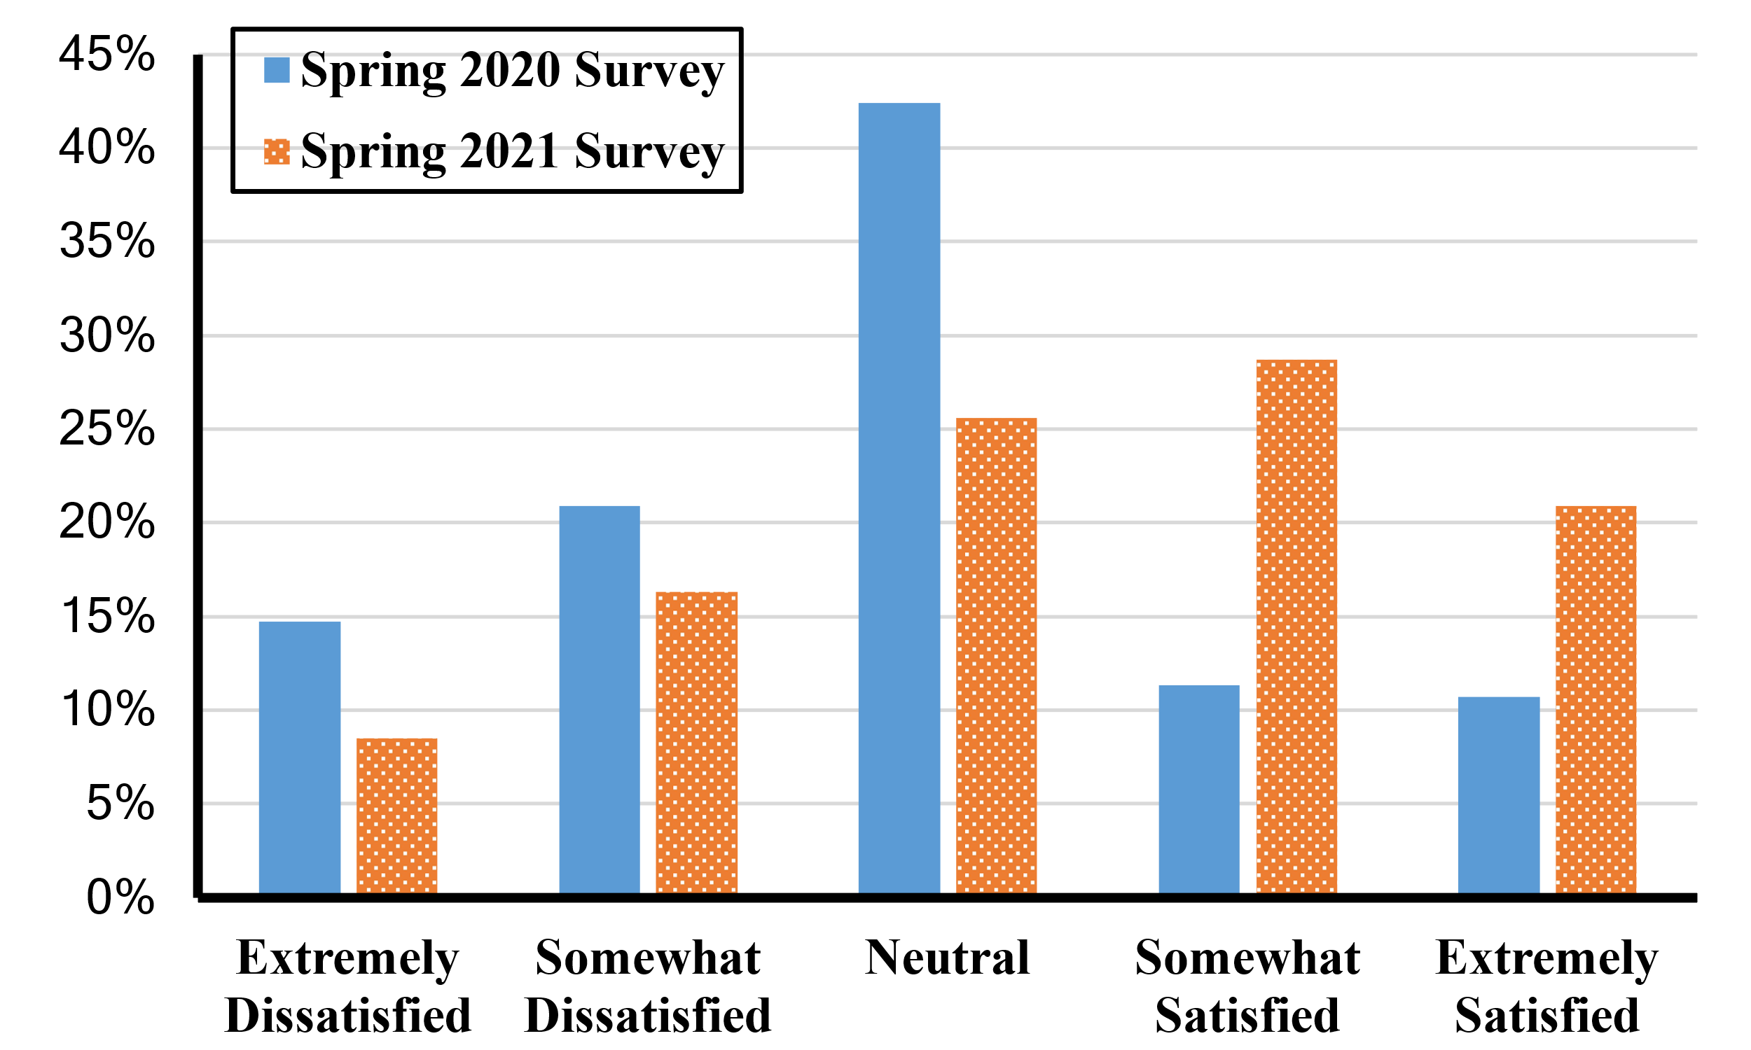
Fig. 4. Question: Which type of online classes are you most comfortable with? | Fig. 5. Question: Overall, how satisfied are you with the availability of resources in your online labs?

In a follow up question, we asked respondents how much of their class time they prefer to spend on lectures vs. activities (e.g., group discussion, practice exercises). 17.9% of the respondents selected 100% lecture, 31.4% selected 80% lecture, 32.7% selected 60% lecture, 12.2% selected 40% lecture and 5.8% selected 20% or less lecture out of all the class time allocation.
A major challenge identified in this study was the grading and assessment policy. When asked about how online testing reflects their understanding of course material, 41.7% of respondents indicated that they were satisfied with online testing, 25.6% answered neutral and 32.7% indicated unsatisfied. The high percentage of negative responses, unfortunately, was not surprising. The university implemented a temporary policy that allowed students to choose between credit/no credit and letter grades on their transcript. Instructors recognized the importance of grading student performance while considering COVID-19 impacts, and some deployed a hybrid grading approach to motivate students. Most of the instructors, however, maintained a traditional grading policy. We have identified designing fair and flexible grading policies in distance learning as a future work.
  - Online Modality
Online modality refers to issues related to the use of technology tools and online functionalities. We found significant improvement in students’ satisfaction rate regarding the availability of online lab resources. The qualitative response indicated the rapidly deployed fully-online classes led to a high percentage of negative responses in Spring 2020 (refer to Fig. 5). In contrast, the percentage of respondents who were satisfied with the online lab resource doubled to 49.6% by Spring 2021. This improvement in lab resources seemed to contribute to the higher satisfaction rate in Spring 2021 as shown in Fig.2. In general, students were satisfied with the technology tools provided by the university, which includes Blackboard, a learning management system; Zoom, Google Cloud and Adobe Creative Cloud. Our results also suggested that students understood the challenges caused by the COVID-19 crisis and appreciated the department’s effort to alleviate these challenges with equipment mailed to their homes.
- Conclusion
Our study showed cautiously optimistic results in online teaching during the pandemic. Given that online and hybrid education will likely be a strategic priority after COVID-19, we hope this study helps faculty better prepare project-based courses in virtual environments. Specifically, for computer engineering capstone courses, the paper summarizes our efforts on how we have better provided students with hands-on experience in solving practical problems and prepare them to adopt a data-driven mindset. Additionally, based on the survey results, we make the following recommendations to improve project-based online teaching:
- In terms of student preferences, faculty can choose between synchronous and asynchronous teaching modalities. However, students clearly appreciate alternatives so a synchronous lecture that is subsequently posted is generally preferred above a single mode. Most preferred is a synchronous lecture and a high-quality, pre-recorded lecture which becomes more realistic as course materials are built up over time. In project-based settings, instructors may want to consider less all-class sessions and substitute shorter individual team briefings.
- It is important to offer a variety of interactive opportunities with the students—full class, small group, virtual office hours, blog sites embedded in the course, and so on —, and to provide feedback in a very timely fashion. Mentor and peer support are also valuable.
- Students in project-based courses are just as eager to have reminders and “ticklers” about assignments and deadlines as students in theory-based classes or components. However, given the nature of the medium and the flexibility inherent in project-based learning, instructors may consider providing auxiliary guidance to students on self-paced and time management strategies.
References
- McManus, J. W., Costello P. J.: Project based learning in computer science: a student and research advisor's perspective. Journal of Computing Sciences in Colleges (2019).
- Kojmane, J., Aboutajeddine, A.: Engineering Junior: A hands-on activity to enhance technological learning in an engineering dynamics course. In: 2016 International Conference on Information Technology for Organizations Development, (2016).
- Lee, S. J., Jung, A., Park J., Yun, M.: Cost-efficient Hands-on Learning Design for Computer Organization Course. In: 15th International Conference on Computer Science & Education on Proceedings, (2020).
- Cassens, M., Reimer,Y.: Engaging CS1 Students With Project Based Learning. In: 2018 IEEE Frontiers in Education Conference, (2018).
- ABET Engineering Accreditation Commission,https://www.abet.org/accreditation/accreditation-criteria/, last accessed 2021/5/29.
- Hou, Y., Muheidat, F., Usher, T., Prado, W., Guo, X., and Van Wart, M.: Evaluation of the COVID-19 shock on STEM laboratory courses. In: IEEE EDUCON 2021, (2021)

