Page: https://cel.csusb.edu/pace/courses-programs/medical-health-care/individualized-supervised-practice-pathways-ispp-dietetic

Please replace the paragraph in this screenshot:
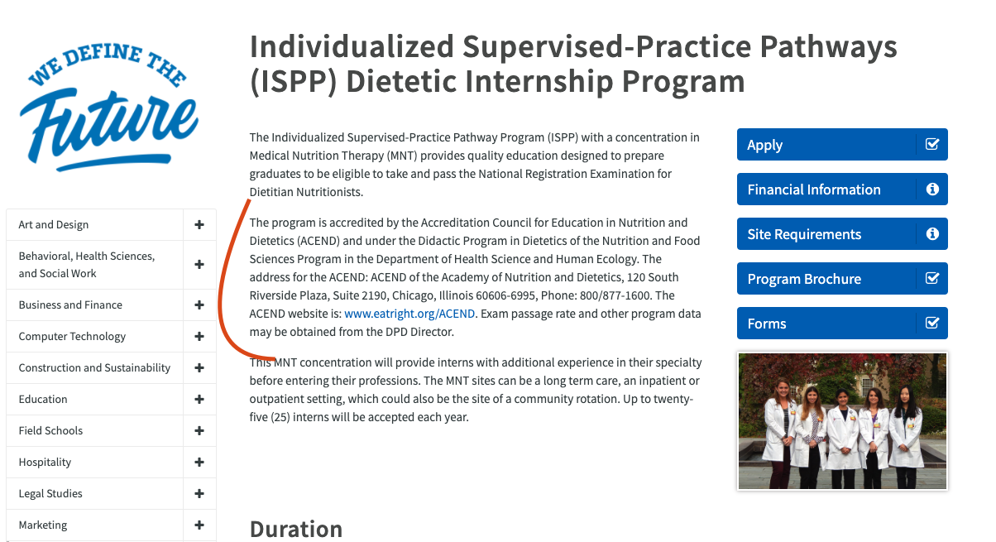

With:

Notice from the Accreditation Council for Education in Nutrition and Dietetics of the Academy of Nutrition and Dietetics (ACEND) regarding CSUSB’s Probationary Accreditation Status
(link to PDF document, “ACEND CSUSB Probationary Accreditation”)
Page: https://cel.csusb.edu/pace/courses-programs/medical-health-care/individualized-supervised-practice-pathways-ispp-dietetic

Section: Program Mission, Goals and Objectives

Header: Mission

The mission of CSUSB’s Nutrition and Food Sciences (NTFS) Program [to be renamed
the Nutritional Science and Dietetics (NSCD) Program in Fall 2020] at CSUSB is to
provide a high-quality education and cultural competencies to prepare students for
supervised-practice leading to eligibility for the Commission on Dietetic Registration
(CDR) credentialing exam to become a registered dietitian nutritionist (RDN). Through
the accredited Didactic Program in Dietetics (DPD) and Individualized Supervised-
Practice Pathway (ISPP) Program, graduates will be prepared academically and
professionally to work in a variety of employment opportunities as an entry-level
registered dietitian nutritionist, who will address the nutrition and health needs of
individuals, families, schools, and communities.

Header: Goal 1

The DPD program will prepare competent graduates capable of succeeding in
an accredited supervised-practice program (dietetic internship or individualized
supervised practice pathway). The DPD and ISPP Programs will prepare graduates
capable of succeeding as entry-level practitioners as a registered dietitian nutritionist
(RDN).
Subheader: Objectives

1.1a: At least 80% of program students will complete the
program/degree requirements within 3 years (150% of program length) for fulltime
students and within 6 years (150% of program length) for part-time students.
(DPD)
1.1b: At least 80% of program interns will complete the
program/degree requirements within 16.5 months (150% of program length) for
full-time and 33 months (150% of program length) for part-time interns. (ISPP)
1.2.a.a: At least 40% of program graduates apply for admission to a
supervised-practice program prior to or within 12 months of graduation. (DPD)
1.2.a.b: At least 25% of program graduates are admitted to a
supervised-practice program within 12 months of graduation. (DPD)
1.2.b: Of graduates who seek employment, 80% are employed in
nutrition and dietetics or related fields, within 12 months of graduation. (ISPP)
1.3.a: At least 80% of program graduates take the CDR credentialing
exam for dietitian nutritionist within 12 months of program completion. (ISPP)
1.3.b: The program’s one-year pass rate (graduates who pass the
registration exam within one year of first attempt) on the CDR credentialing exam
for dietitian nutritionists is at least 80%. (DPD and ISPP)
1.4.a: At least 90% of supervised-practice program directors, who
respond to the program survey, will indicate that they were satisfied or very
satisfied with the level of academic preparation of the DPD graduate(s) whom
they supervised as interns. (DPD and ISPP)
1.4.b.1: At least 90% of the employers of DPD graduates, who
respond to the program survey, will rate these graduates as “competent” or
“extremely competent” for their performance as dietetic professionals. (DPD)
1.4.b.2: At least 90% of employers, who respond to the program
survey, will rate ISPP graduates as having “adequate” or “extremely adequate”
competency to work as an entry level dietitian nutritionist. (ISPP)
1.5.a: At least 80% of DPD graduates, who respond to the program
survey, will self-rate that the program “prepared” or “well-prepared” them to be
successful in a supervised-practice program, a related graduate program, and/or
employment in a nutrition and dietetic related position. (DPD)
1.5.b: At least 80% of ISPP graduates, who respond to the program
survey, will self-rate that the program “prepared” or “well-prepared” them to be
successful in employment in a nutrition and dietetic related position. (ISPP)
1.6.a: At least 80% of DPD graduates, who respond to the program
survey, will also rate the education at CSUSB to be “good” or “excellent.” (DPD)
Objection 1.6b: At least 80% of ISPP graduates, who respond to the program
survey, will also rate the education at CSUSB to be “good” or “excellent.” (ISPP)

Header: Goal 2

The DPD/ISPP will prepare graduates competent in a variety of employment
opportunities that will address the nutrition and health needs in multicultural
communities.

Subheader: Objectives
2.1: At least 90% of supervised-practice program directors, who
respond to the program survey, will rate the DPD graduate(s) completing their
program as “competent” or “extremely competent” in their ability of provide
service to culturally diverse communities. (DPD and ISPP)
2.2: At least 80% of DPD/ISPP graduates, who respond to the
program survey, will self-rate themselves “competent” or “extremely competent”
in their ability to work with clients of various ethnic/cultural backgrounds (DPD
and ISPP)
2.3: At least 90% of employers, who respond to the program survey,
will rate ISPP graduates as being “competent” or “extremely competent” to work
with clients of various ethnic/cultural backgrounds. (DPD and ISPP)
Page: https://cel.csusb.edu/pace/courses-programs/medical-health-care/individualized-supervised-practice-pathwaysdietetics/apply

2020-21 Application Period

On April 7, DICAS will reopen for second round matching process. You may update the material (including grades for Winter quarter, new personal statement for ISPP, etc.). You do NOT have to do D and D Digital for this round of application.

Process:

- After you update the DICAS information, set the designation to CSUSB-ISPP, and pay $20 for DICAS to send your application to CSUSB. If you have applied before and the application is not in the current year, you may be charged $40.
- Complete the secondary application for CSUSB ISPP. On this page, you will also find a brochure that describes CSUSB ISPP program and the rubric for us to evaluate the applicants. If you are a CSUSB graduate, you don't need to have an interview so skip the interview date and times. You don't need to have sites for rotations if you are our local interns.
- Submit the secondary application by following the instructions online and submit the application fee of $75 along with your application.

We will be reviewing the applications as we receive them and accept or waitlist the interns so it may be best for you to submit your applications as soon as possible. If you have any questions, please do not hesitate to contact me. We look forward to reviewing your application.

Contact Information:
Dorothy Chen-Maynard, PhD, RDN, FAND
Program Coordinator, Nutrition and Food Sciences
Director, Didactic Program in Dietetics
Email: dchen@csusb.edu
Phone: (909) 537-5340

2020-21 ISPP Program Brochure (Link to PDF document, “ISPP 2020-21 Brochure”)

Who is Eligible to Apply?
Qualified DPD graduates with a verification statement from DPD who were not previously matched to a DI program.

This is an online program that does not satisfy immigration requirements for a full-time, matriculated student visa and therefore, the College of Extended and Global Education cannot issue or accept a transfer of I-20.

