Hosting Accessible Zoom Meetings
Spring 2020

Table of Contents
Hosting Accessible Zoom Meetings Spring 2020 1
Introduction 3
Considerations Prior to Zooming 3
Invite Participants to Ask for Assistance in Advance 3
Make Materials Available in Advance for Audio-Only Participants 3
Be Aware of FERPA 3
Accessibility Settings in Zoom 4
Set Up Captioning Options 4
Enable Automatically-Generated Transcripts 4
Accessibility Best Practices During Zoom Sessions 5
Assign a Participant to Provide Closed Captions 5
Provide Multiple Means of Perception 5
After the Zoom Session 5
Resources 5

Introduction
All CSUSB community members have Zoom accounts that can be accessed through myCoyote by selecting “Collaborate” and then “Video Conferencing” or by logging in to the CSUSB Zoom portal. With Zoom you can host meetings, class sessions, and a variety of other synchronous activities. This guide will help ensure that interactions delivered via Zoom are accessible to CSUSB students, faculty, and staff with a wide variety of abilities and learning preferences.

Getting Prepared
By giving some consideration to the below items ahead of time, you can mitigate potential accessibility pitfalls. The guidelines in this section are intended to be implemented prior to the start of a Zoom meeting.

Invite Participants to Ask for Assistance in Advance
The sooner you know that a participant will require alternative access, the more time you will have to plan. Actively encourage individuals to speak up about their needs so you will have awareness of barriers they may be experiencing.
As part of the Zoom meeting invite, include the following:
- Send the dates and time of recurring meetings
- Encourage individuals who need an accommodation to contact you as soon as possible
- Provide multiple ways for participants to contact you

Make Materials Available in Advance for Audio-Only Participants
Some meeting participants may join your meeting via the audio-only (call-in) option. There are several reasons why a participant would choose to join the meeting via audio call:
- Limited or no access to a computer or device
- Limited or no internet access
- A screen reader user who prefers to separate Zoom meeting audio from their screen reader audio to make it easier to follow along

To ensure that participants who are joining your meeting via audio-only are still able to follow your Zoom meeting, make all presentation materials or resources available online before the meeting. There are several ways to facilitate this access:
- In the Blackboard LMS
- Cloud storage such as OneDrive or Google Drive
- As an email attachment

Enable Automatically-Generated Transcripts
If you record your Zoom session to the cloud, Zoom can automatically provide a machine-generated audio transcript. Participants can use the transcript as a rough written record of the meeting, search for keywords, and use it to help with retention of presented content. When this option is selected, the transcript is added to the recorded meeting and can be viewed by clicking the “CC” button. The transcript file can also be viewed and shared independently of the video. Share the links to the recording and the transcript to participants once they become available. Please note, processing times for recordings take at least as long as the recording time.
While the audio transcription feature can be beneficial for many, this transcript does not substitute the need for real-time captions in a meeting for a participant with captioning accommodations.
- Log in to your Zoom account
- Click on Settings, select the Recording tab, and click the Audio Transcript checkbox.
- This setting only applies to recordings saved to the Zoom cloud, not those on a local machine.

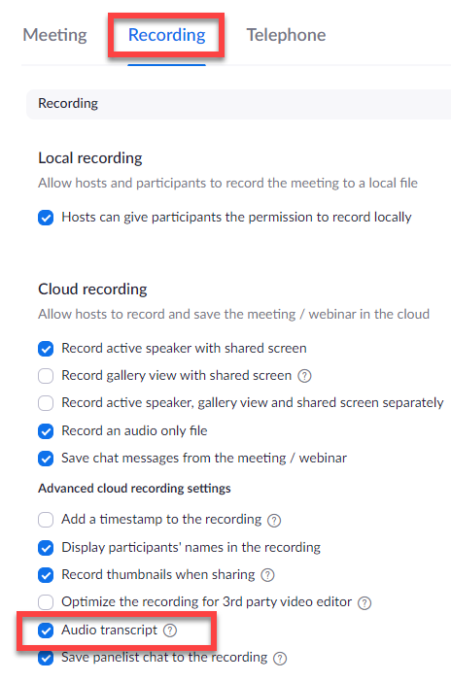

Be Aware of FERPA
Do not post videos where student names or faces are visible --including recorded Zoom sessions--to any public site (such as a YouTube or Vimeo video set to public). Allowing people outside of the class to see students violates privacy and the Family Educational Rights and Privacy Act (FERPA). For more information, contact Academic Technologies and Innovation.

Ensuring Equal Access for Deaf or Hard of Hearing Participants
The need to accommodate a participant in a Zoom meeting may occur spontaneously. By ensuring that the following best practices are implemented, you will be better prepared to adapt to requests. When logged in to your Zoom account, enable the following options in the default settings. All future meetings will use these settings. If desired, the host can change settings for a specific meeting.

Set Up Captioning Options
These options will allow for adding captions to a live Zoom session.
- From the Zoom main page, click on “Settings” in the left-hand navigation
- Under the “Meeting tab” select “In Meeting (Advanced)”
- Enable the following options:
  - Closed Captioning
  - Save Captions
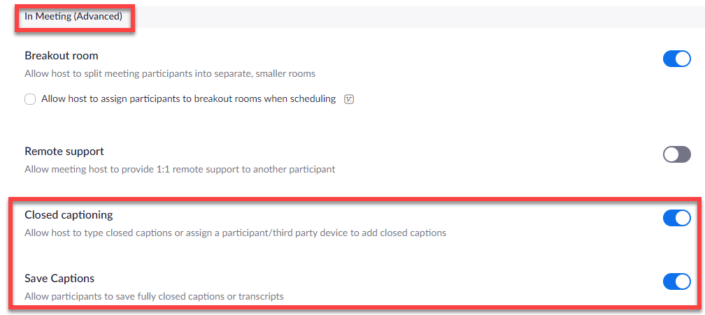

Assign a Participant to Provide Closed Captions
You can designate an attendee to type real-time captions at the beginning of a Zoom meeting. This designee is typically a certified transcriber that has been trained in captioning best practices and has been assigned to your course through Services for Students with Disabilities (SSD).
SSD will notify you if you have a participant that is receiving real-time captioning accommodations and will arrange for a professional to provide closed captions for your Zoom meeting. Provide the Zoom join meeting URL to ssd@csusb.edu so they can provide the information to the assigned captionist. SSD will give you the captionist’s contact information.
When the meeting begins and the captionist joins, the host should follow these steps:
- Click “Manage Participants” at the bottom of the Zoom meeting window
- In the Participants List window, click the captionist’s name (they will self-identify)
- Click the “More” button, then choose “Assign to type Closed Captions”
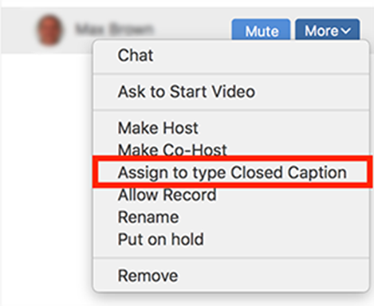

A notification will appear that closed captions are available. Participants can select the “CC” button to view captions and can adjust their size by clicking Video Settings> Accessibility, then adjusting the closed caption slider.

ASL Interpreters
If you have a Deaf-or-Hard of hearing participant that is receiving sign language interpretation (ASL) in your Zoom meeting, remind the student to pin the video feed of the sign language interpreter so that the feed will always be in view. Ensure you are giving the interpreter time to relay content, especially when a participant is asking a question.

Prerecorded Multimedia
If you are showing a video or other pre-recorded content during your Zoom meeting, ensure it has closed captions.
If you have a hired captionist assigned, they will NOT provide captions for pre-recorded media. Their role is to caption only the audio of presenters and participants.

Selecting Content to Share
- If there are several versions of a video available, choose one that has captions. In YouTube, you can filter video results and only show those that have proper captions. YouTube’s autogenerated captions are insufficient for equal access.
- If a captioned version is unavailable, contact accessibility@csusb.edu to arrange for captions. Turnaround time for this service is about 3 business days.
- For audio-only recordings, a transcript must be provided. If a transcript is unavailable, contact accessibility@csusb.edu .

Ensuring Equal Access for Blind and Low Vision Participants
The following guidelines ensure all participants can perceive shared information:
- If you are sharing materials in a meeting, fully describe the content out loud while sharing your screen.
- In advance of the meeting, provide access to resources that will be shared. Consider the accessibility of documents prior to posting to Blackboard, sharing via cloud storage, or sending via email.
  - Post the outline view of PowerPoint presentations used in the meeting
  - Post Word documents instead of PDFs, when possible
- Participants should identify themselves when they speak.
- Allow participants to respond to polls or questions via multiple methods:
  - Chat
  - Audio
  - Email
- If addressing questions from the chat window, speak the question aloud before answering to ensure everyone can participate.
- Place URLs that are referenced in the meeting in the chat window.

Ask for Feedback from Participants
Proactively invite participants to comment on any pain points they may have experienced soon after your initial meeting and well before future sessions. A follow-up email to invite feedback may give you additional time to make any required alterations to your format to ensure equal access. Keep an open dialogue with participants to ensure that you are eliminating barriers wherever you can.
Taking a proactive stance and maintaining flexibility will allow community members to access content via the modalities that work best for them.

On-Campus Support Resources
Below are campus resources to provide additional support in navigating Zoom.

Accessible Technology Services (ATS)
For accessibility support, including video captioning and document creation, or for questions about this guide, visit the ATS website or contact accessibility@csusb.edu or (909) 537-5079.

Assistive Technology Center (ATC)
If a participant is an assistive technology user and experiences difficulty using Zoom, they should contact the ATC for support and training by visiting the ATC website, emailing accessibility@csusb.edu, or calling (909) 537-3472.

Academic Technologies and Innovation (ATI)
For general Zoom support or training, contact Academic Technologies and Innovation at ati@csusb.edu or (909) 537-7439.

Services to Students with Disabilities (SSD)
For questions regarding specific accommodations and to schedule interpreters or captionists, contact SSD at ssd@csusb.edu or (909) 537-5238.

Technology Support Center (TSC)
For downloads, troubleshooting, and 24 hour support, open a ticket with the Technology Support Center by calling (909) 537-7677 or emailing support@csusb.edu.

Zoom Support Resources
There are a variety of online training videos from Zoom. Below you will find pertinent links to Zoom support resources for educators, those that pertain to accessibility, and the most frequently asked support topics:
- Zoom for Educators Pre-Recorded Webinar
- Zoom Accessibility Features
- Viewing Closed Captions (Functionality must be enabled and assigned in advance)
- Full List of Hot Keys and Keyboard Shortcuts for Zoom
- Getting Started with iOS Zoom Client
- Testing Computer or Device Audio
- How Do I Test My Video?
- Zoom Status

