Division of Student Affairs Assessment Committee (A-Team)

February 9, 2021

AGENDA WITH MEETING NOTES

Participants:
Jasmine Bustillos, Natalie Cleary, Jackie Valera, Daria Graham, Veronica Guzman, Jesse Juarez, Jennifer Mersman, Pamela Moses, Ben Toubak, Conrad Valdez, Mike Wong

See Teams for 2021 Zoom Recordings

- Updates and Announcements
  - Volunteers to organize brief ice-breakers for meetings
A-Team Meeting | Volunteer to coordinate kick-off activity
Feb 9 | Conrad Valdez
Feb 23 | Jasmine Bustillos
Mar 9
Mar 23 | Avi Rodriguez
Apr 6 | Jason Wimbley and Jesse Juarez
Apr 20
May 4
May 18
Conrad led us in a work-week forcast in the styling of Dr. Suess.
  - ZOOM ZOOM ZOOM with a DEI BOOM. Programs Galore with no more room!
  - The week will be busy with meetings, for which there will be an exchange of many greetings.
  - I have a lot of progress to make, I do do. Meetings for everyone; including for me and for you! :)
  - Data data everywhere, so much data to gather and share
  - but that is not all. oh no. that is not all
  - The two children looked out the window and exclaimed: “Cloudy with a certainty of an interview mid-week,” “How will we make it Friday from today?"
  - Opened my planner only to find meeting upon meeting time after time

  - Follow up on sampling method for NSSE: see IR’s link to surveys, and 2018 Survey Administration Summary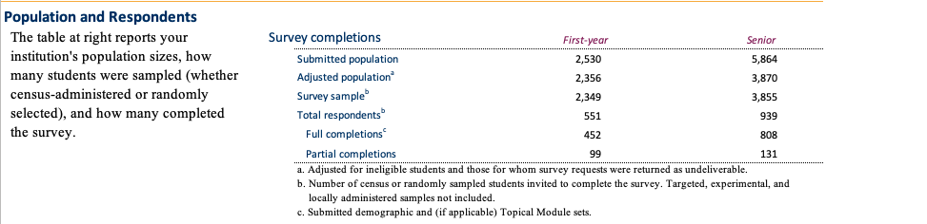
  - Check in on campus labs midstream assessment in December

- Cumulative approach to assessing DLO’s in Current Student Survey
  - See PPT: consistent set of items asked across different DLO’s from year to year. Our job will be to determine the list of programs/events that will be listed
  - Decisions on Process: Informed on Feb 8 that the deadline moved from April 1 to Feb 10. As a committee, do we decide to move forward imperfectly with this, or hold off until next year? Decision: move forward and consider it a pilot.
  - Recognizing that our planned, systematic method for developing inclusion criteria and rough mapping cannot happen, what can we decide upon today?
    - Blunt analysis of the critical programs to include in the list for the survey. Consider alignment of outcomes first, then reach, level of participation, potential for impact.
    - Jacob created excel file in Teams to quickly capture. Reach out to ASI. Other department not represented here that major event in DLO 2.2??

- Campus Labs Student Affairs Assessment Credential
  - Follow up from last training: apply and practice Decided to hold until next time (if people think it is worthwhile) since CSS was a longer, time sensitive issue.
Learning Outcomes Worksheet
- split into groups and do activity #1.
- Do activity #2 as a whole group, fill in answers on shared screen
- Activity #3 workshop these outcomes in breakout groups:
  - The SMSU/RW will foster wellness within the workplace by participating in activities that help promote work-life balance.
  - Students will identify the importance of community in their collegiate experience
  - Residential students will engage in academic, professional, and personal development that they can apply to their individual goals.
- How can this committee assist in refining outcomes across units/programs? Once the assessment template is finalized and shared, there will be a lot of activity in this area: how do we prepare?
Assessment Planning Worksheet : show as resource

  - Today’s training: Selecting Methods for Student Affairs Assessment (1.06 minutes)
    - Start with the assessment question, don’t skip rationale and purpose before going to assessment methodology and instruments. Often times people start with the data collection before really nailing the assessment question and this makes subsequent steps in the assessment cycle more difficult.
    - Stakeholder slide: students should be considered primary stakeholder group, not secondary or tertiary
    - Mike: seeing the table on purpose statements was helpful in rethinking how we can better word them.
    - Pamela: backward design to plan to make the data actionable. Consider the scenario if you get what you’d think are really poor/good results: what can I do with that data?
    - Thinking about costs more broadly: opportunity costs. Today is prime example—what will be lost if an alternative path (or no path) is chosen? Lo’s of practical concerns to factor into methodological issues.
- Action Items
  - Review rescheduled learning activity (agenda item 3A), give Jennifer feedback on usefulness of doing activity

- Discussion items for next meeting
  - Check in on campus labs midstream assessment in December

- Upcoming Meetings:
- Feb 23, 2021 09:00 AM
- Mar 9, 2021 09:00 AM
- Mar 23, 2021 09:00 AM
- Apr 6, 2021 09:00 AM
- Apr 20, 2021 09:00 AM
- May 4, 2021 09:00 AM
- May 18, 2021 09:00 AM
- Upcoming trainings in Campus Labs Credential
Lesson 5: Assessment Methods and Data Collection
  - Focus Groups: An Underutilized Assessment Tool (55 minutes)
  - Make Rubrics a Best Practice at Your Institution (53 min))
Lesson 6: Analyzing Assessment Results and Research Literacy
  - Analyzing Student Affairs Assessment Results (33 minutes)

Assignment: Create and submit Assessment Project Plan using the "Assessment Project" template, available to download below (email to assessmentcredential@campuslabs.com).

Lesson 7: Communicating and Using Assessment Results
  - Closing the Loop on Student Affairs Assessment: Sharing and Using Assessment Results (37 min)
  - Writing Assessment Reports (video) (42 min)
  - Closing the Assessment Loop: Making Informed Decisions (47 min)

