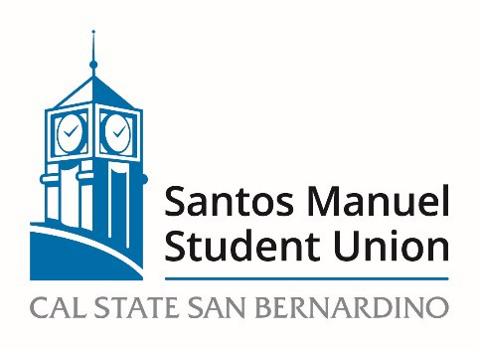

California State University, San Bernardino

Santos Manuel Student Union Board of Directors

Policies and Procedures Committee

August 25, 2022

https://csusb.zoom.us/j/89915083410

Agenda

Call to Order
Roll Call
Approval of Minutes from April 22, 2022
Open Forum
Adoption of Agenda
NEW BUSINESS:
PC 01/23 Election of Committee Chair

PC 02/23 Review of Cash Handling Procedures for SMSU Operations (Action, Felix)

Announcements

Adjournment

