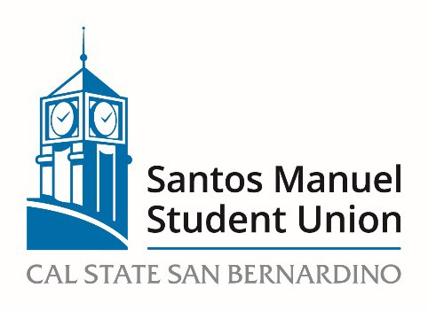

California State University, San Bernardino

Santos Manuel Student Union Board of Directors

Policies and Procedures Committee

April 20, 2023

https://csusb.zoom.us/j/81272165888

Agenda

Call to Order
Roll Call
Approval of Minutes from March 16, 2023
Open Forum
Adoption of Agenda
NEW BUSINESS:
PC 09/223 Review and approval of Hospitality Policy (Action, Felix)

Announcements

Adjournment

