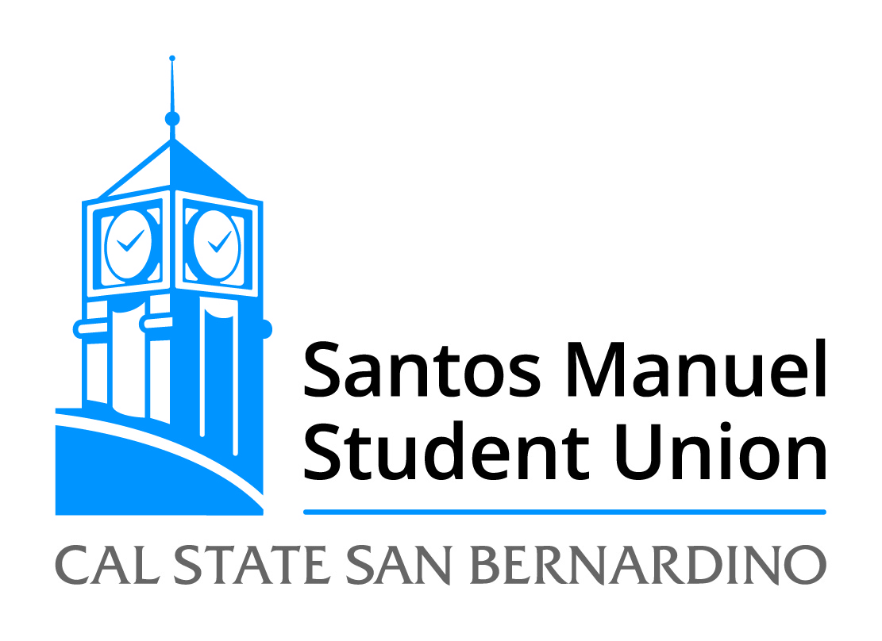
California State University, San Bernardino
Santos Manuel Student Union Board of Directors
Facilities and Sustainability Committee
Tuesday, April 19, 2022
2:00 p.m. – Zoom: https://csusb.zoom.us/j/89041495368
Agenda

Call to Order
Roll Call
Approval of Facilities and Sustainability Minutes from March 4, 2022
Open Forum
Adoption of Agenda

Old Business:
FAS 8/22 Review Space Usage (Discussion)

FAS 9/22 Review Sustainability Efforts (Discussion)

New Business:

FAS 10/22 Review of Rancho Mirage Student Center Summer Construction Project (Discussion)

FAS 11/22 Review of Mural Project in the SMSUN (Discussion)

Announcements

Adjournment

