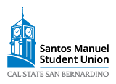
SANTOS MANUEL STUDENT UNION BOARD OF DIRECTORS MEETING
November 8th, 2023 --- 2:00 PM

Due to an urgent matter, this meeting has been cancelled.

Apologies for the inconvenience.

